GATE 1
SUBMISSIONS

LEARNING RANGE

WORKING TITLE | ONCE UPON A DUPLO
REFERENCE # | LNG002PC01
PROJECT TYPE | INTERNAL
DESCRIPTION | Play, learn and teach the power and the fun of words in a story-based adventure that you help to create. Find and place word bricks to complete sentences to advance the story. Choose an appropriate or silly word brick and watch the screen come alive.  A story begins. For example, the elephant, who is most forgetful, tells a story but he can’t seem to remember some of the details. That’s where you come in. When the elephant forgets the word he needs, the sentence appears in text and the missing word is replaced with a brick that is labeled “Verb, Noun or Adjective” and you select a word from your collected inventory. Your inventory are bricks that vary in size and color that matches the missing word brick. Noun (yellow), Verb (red) and Adjective (green) have a word decal on the side of each brick and a roll over will pronounce the word.  For example, “ When our friend, the monkey reached the river, he needed to _____” (a red brick to match is in place of the word).  Do you select the verb brick to jump, swim or sleep?  The results of your choice come to life and the story continues. Sometimes Sing-Alongs occur with the words you select.  Have great inventive fun storytelling while learning vocabulary, spelling and communications.
FEATURES | - Reading, vocabulary, phonics and spelling through inventive fun and storytelling.  - Constructive builds with words and concepts for a visual understanding of symbols and sounds to meaning.  - Learning with creativity: Play to Learn to Teach  - Richly rendered 3D graphics, personality driven characters in engaging and humorous stories.  - It really is fun for the whole family with some pretty silly results.
TARGET | Boys and girls age 4 to 6 and the parents of these gifted kindergarten scholars. The parents are the primary marketing target. The children are the primary users.
RANGE | Learning Range
ESP | A learning product that is genuinely fun for the whole family.  Learn at one’s own pace. Be silly or serious. No right or wrong choices. Reading, spelling, phonics, vocabulary presented as fun and not a passive involvement in “Drill and Kill.”
COMPETITION | - Orly’s Draw a Story  - Non computer products like Mad Libs, Poetry Magnets and Scrabble but designed for Kindergarten age.
PLATFORM | PC / CD ROM  Windows 95/98 with Direct X  Pentium Processor 200Mhz  32Mb  sound, mouse, keyboard
COMMENTS
SIGNATURE

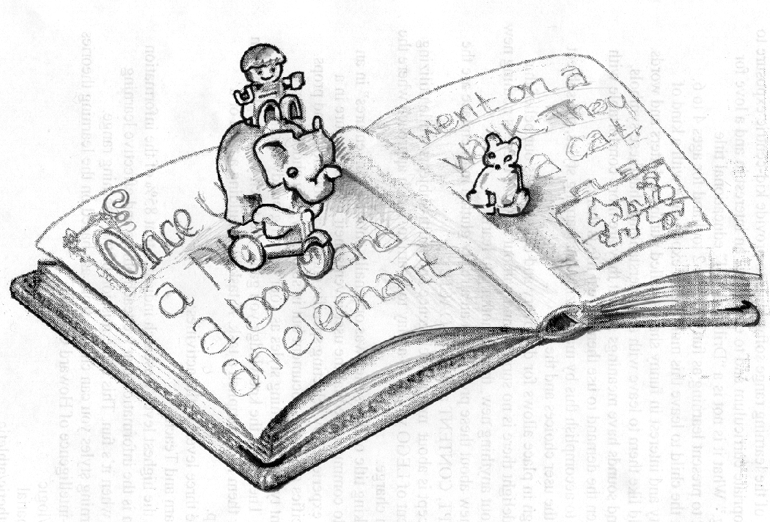

Once Upon A Duplo is a reading, spelling, vocabulary and phonics product designed as a fun constructive word game in a storybook fashion. Our storyteller begins the story and forgets a word or, at times, asks you to take it from there.

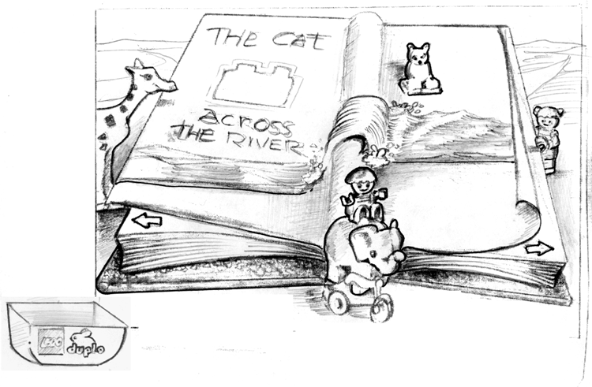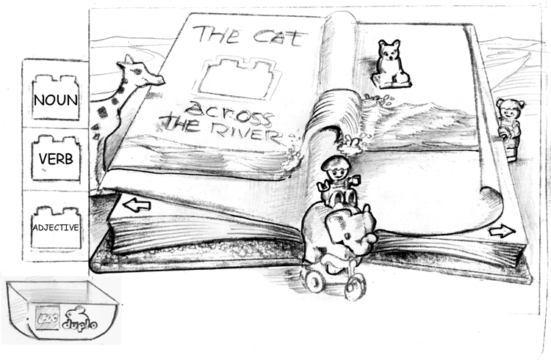
The forgetful elephant says” The cat does something across the river and I can’t remember what he does.” I first select my Toy Box for the color-coded grammar selections of Noun, Verb or Adjective. I’ve learned what these are during level one dialogues and by matching the colors, I can tell I need a verb.

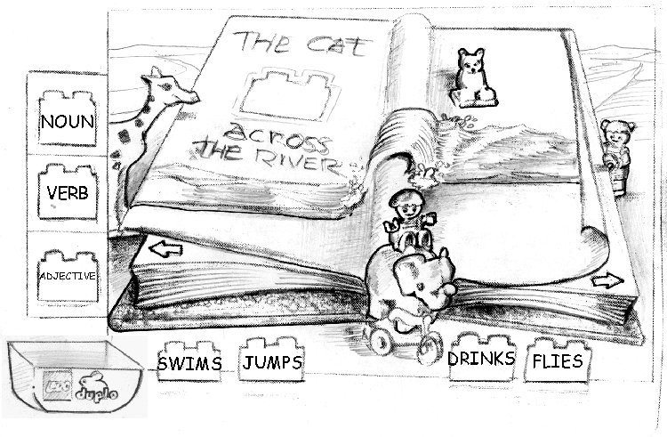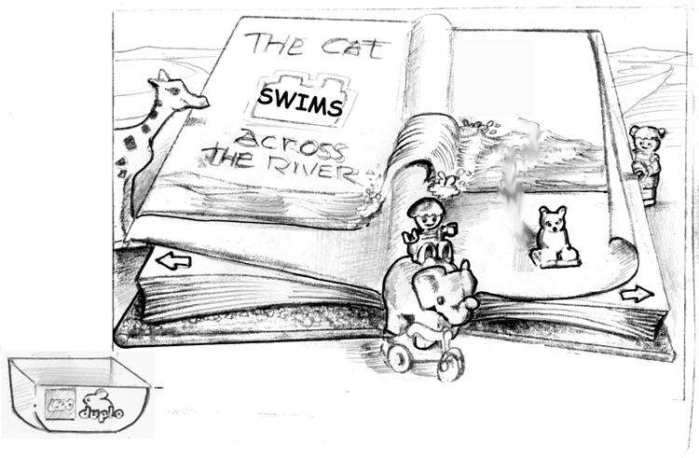
I select verb because I’m smart and because I matched the color of the blank brick in the book. It then reveals the inventory of collected verbs.
I think and decide that the cat ‘swims’ across the river. I select swim and place it in the book. This triggers an animation and continues the story. I am free to either turn the page and see what happens next or close the book and look for more words. The book is then accessible when I want to come back . It’s in my Toy Box.

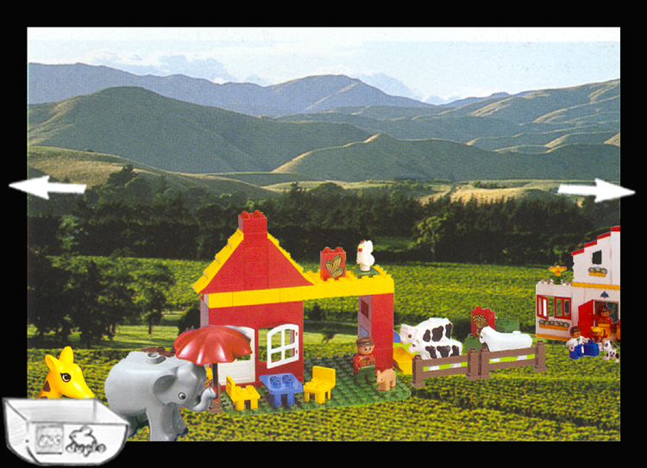

As in all Learning Range products, the free form explore area is a scroll
environment that is hotspot rich. Here’s where you explore and discover words to collect and put them in your Toy Box for using in your story.

Re-cap diagram of how the story interaction works

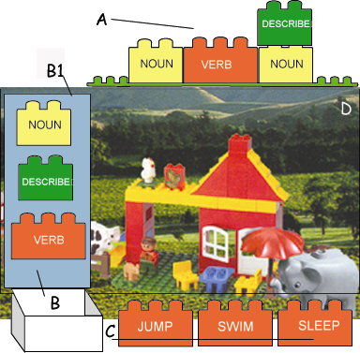

Full screen as an animated story is told.

- When, during the animated story telling, the word in a sentence is forgotten by the elephant, that sentence appears on top of the screen with a brick to be matched labeled “Verb”. The sentence may read. “The cat will (brick) across the river.”
- You select the Toy Box to release your inventory (B1), which is a verb brick, a noun brick and a descriptive word brick.

You select the matched brick. In this case a verb is needed. The inventory will spill across the bottom allowing you to select any word. Click and your cursor is that brick click again on its match and it’ll drop in place. The story continues with your chosen word in place.

