GATE 1
SUBMISSIONS

LEARNING RANGE

WORKING TITLE | ONCE UPON A DUPLO
REFERENCE # | LNG002PC01
PROJECT TYPE | INTERNAL
DESCRIPTION  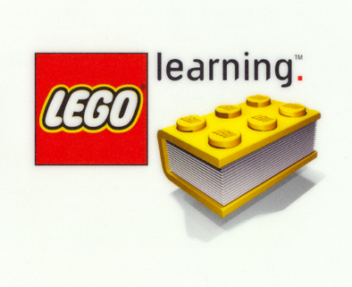  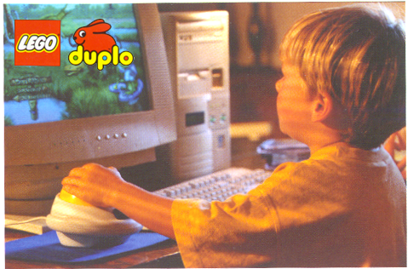 | Play, learn and teach with the powerful fun of words in a story-based adventure that you help to create. Find and place word bricks to complete sentences that advance the story. Choose an appropriate or silly word brick and watch the screen come alive.  A story begins. For example, the elephant, who is most forgetful, begins to tell a story but he can’t seem to remember some of the details. That’s where you come in. When the elephant forgets the word he needs, the sentence appears on screen in text and the missing word is replaced with a brick that is labeled “Verb, Noun or Adjective” and you select a word from your collected inventory. Your inventory are bricks that vary in size,shape and color that matches the missing word brick. Noun (yellow), Verb (red) and Adjective (green) bricks have a word decal on the side and a cursor roll over will pronounce the word.  For example, “ When our friend, the cat reached the river, he needed to _____” (a red brick to match is in place of the word).  Do you select the verb brick to jump, swim or fly?  The results of your choice come to life and the story continues. Sometime Sing-Alongs occur with the words you select.  Have great inventive fun storytelling while learning vocabulary, spelling, reading, phonics and communications.
FEATURES  B.O.B.B. | - Reading, vocabulary, phonics and spelling through inventive fun and storytelling.  - Constructive builds with words and concepts for a visual understanding of how symbols and sounds lead to meaning.  - Learning with creativity: Play to Learn to Teach  - Richly rendered 3D graphics, personality driven characters in engaging and humorous stories.  - It is fun for the whole family with the possibility of some pretty silly results.  - Exposure to school readiness skills
TARGET | Boys and girls age 4 to 6 and the parents of these gifted kindergarten scholars. The parents are the primary marketing target. The children are the primary users.
RANGE | Learning Range
ESP | A learning product that is genuinely fun for the whole family.  Learn at one’s own pace. Be silly or serious. No right or wrong choices. Reading, spelling, phonics, vocabulary presented as fun and not a passive involvement in “Drill and Kill” but rather reading readiness.
COMPETITION | - Orly’s Draw a Story  - Reader Rabbit  - Let’s Go Read/Edmark  - Bailey’s Book House  - Non-computer products like Mad Libs, Poetry Magnets and Scrabble but designed for the Kindergarten age.
PLATFORM | PC / CD ROM  Windows 95/98 with Direct X  Pentium Processor 200Mhz  32Mb  sound, mouse, keyboard
COMMENTS
SIGNATURE

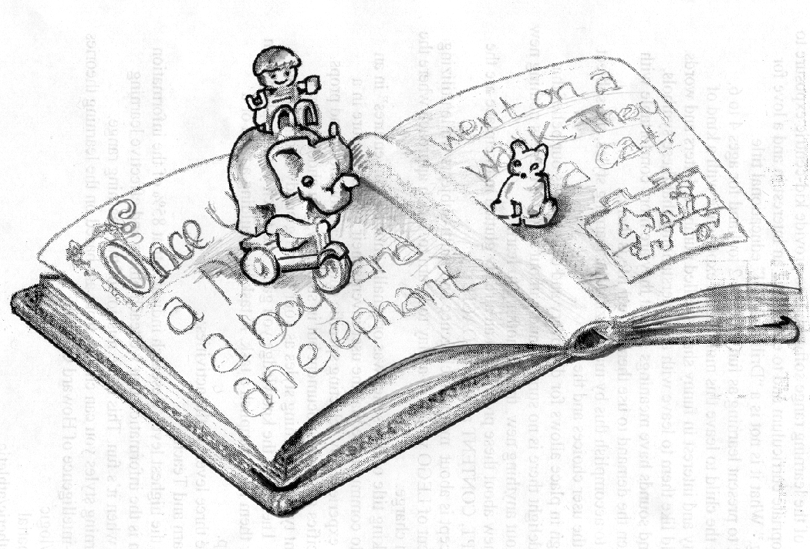

Once Upon A Duplo is a reading, spelling, vocabulary and phonics product designed as a fun constructive word game in a storybook fashion. Our storyteller begins the story and forgets a word or, at times, asks you to take it from there. (Print product tie-ins)

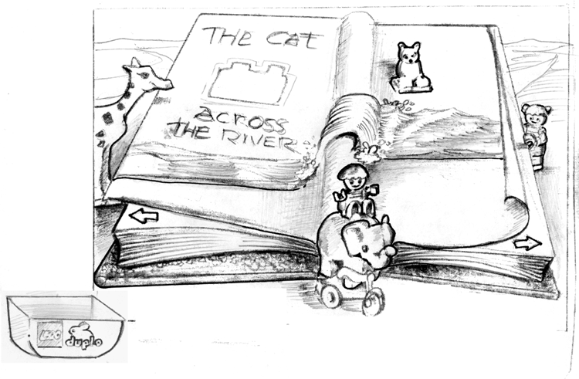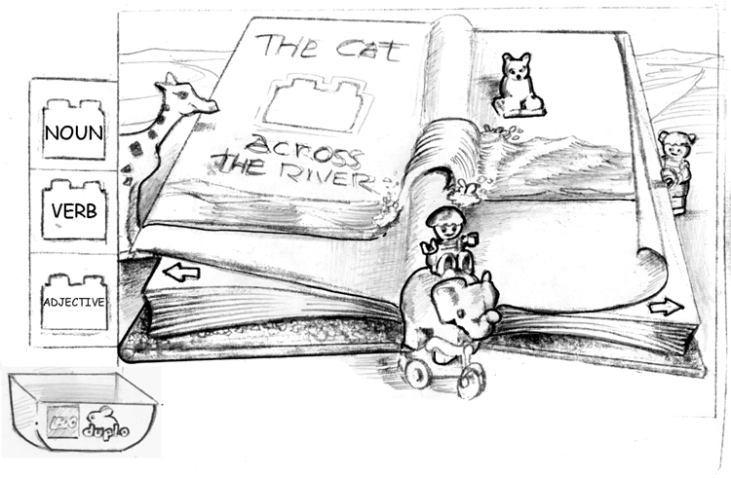
The forgetful elephant says, ” The cat does something across the river and I can’t remember what he does.” I first select my Toy Box for the color-coded grammar selections of Noun, Verb or Adjective. I’ve learned what these are during level one dialogues and by matching the colors, I can tell I need a verb.

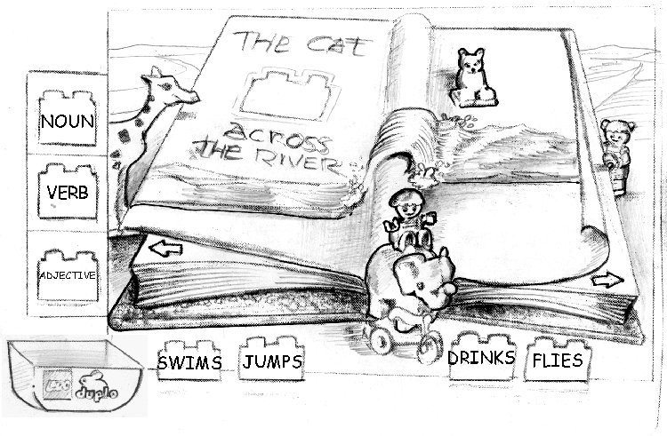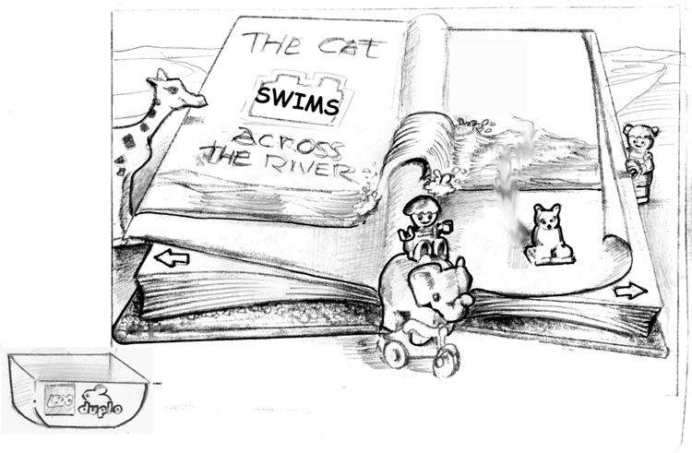
I select the verb because I’m smart and because I matched the color of the blank brick in the book. It then reveals the inventory of collected verbs.
I think and decide that the cat should ‘swim’ across the river. I select “swims” and place it in the book. This triggers an animation and continues the story.

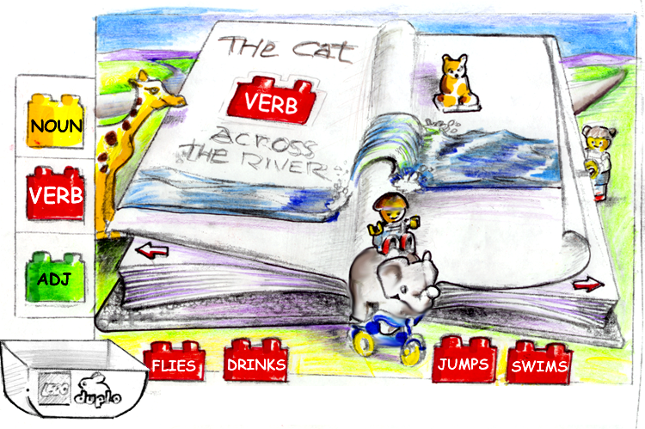
I am free to either turn the page and see what happens next or close the book and look for more words. The book is then accessible any time I want to come back because it’s in my Toy Box.
Roll-over on bricks will trigger an animation plus the word is said.

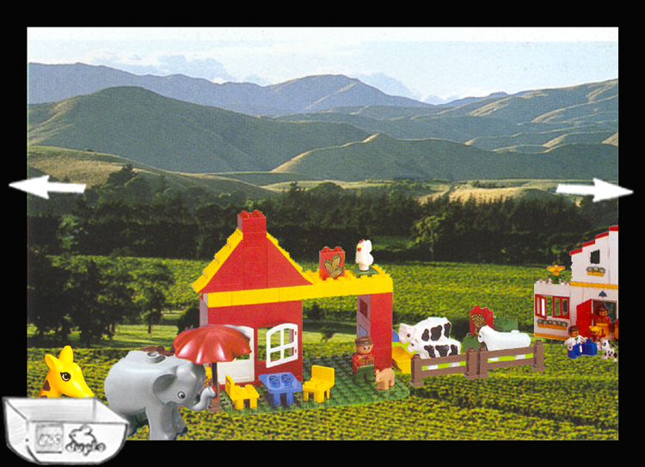

As in all Learning Range products, the free form explore area is a scroll
environment that is hotspot rich. Here’s where you explore and discover words to collect and put them in your Toy Box for using in your story. To return to the story, select the Toy Box and open the book!

Re-cap diagram of how the story interaction works

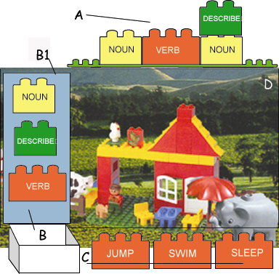

Full screen as an animated story is told.

- When, during the animated story telling, the word in a sentence is forgotten by the elephant, that sentence appears on top of the screen with a brick to be matched labeled “Verb”. The sentence may read. “The cat will (brick) across the river.”
- You select the Toy Box to release your inventory (B1), which is a verb brick, a noun brick and a descriptive word brick.

You select a matching brick. In this case a verb is needed. The inventory will spill across the bottom allowing you to select any word. Click and your cursor is that brick, click again on its match and it’ll drop in place. The story continues with your chosen word in place.

