KidsPower

The Ultimate Racing Challenge for young Boyz

Speed & Inventiveness

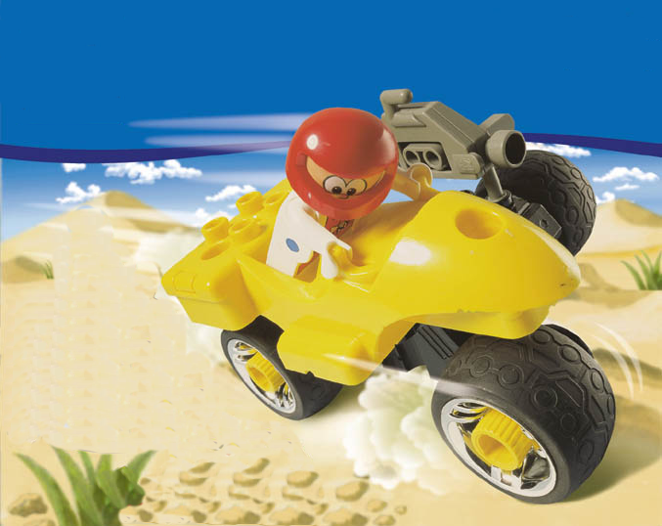

Concept Development Group

LEGO Media International

October 99

Working Title: KidsPower Challenge

Project Type: Racing and Creativity Game

Project Description:

This idea regards the idea of developing a creative racing game based on the play-materials product line named KidsPower. The play-material product line can characterized by the following:

- Action oriented (includes motorcycles, racing cars and helicopters)
- Easy-to-handle and construct (big elements and few steps)
- Robust (based on the LEGO Toolo principles)
- Many design opportunities (lots of secondary models)

The idea is to create a game that has the similar qualities.

A rough out-line of the concept goes:

Turbo Tom is a professional dare devil and racing driver and our main character. He has been invited to participate in the Premiere Challenge Tournament. Before the tournament races take place cars, motorcycles and helicopters are to be designed and constructed.

These constructions take place in a garage located in the cave. It is here Tom constructs his racing vehicles together with his mechanics Mio and Mike. The garage contains different modules from which Tom can build the needed racing devices.

The different modules include: Wheels, wings, propeller, boosters for improved speed, radar for guidance system, alarm for attention etc. All modules have both influences on how the racing device looks and acts. Different set-ups fit different missions and environments. When designing and thereby setting up the device the interface is a point and click interface – and uses the principles behind GOOP (Graphical object oriented programming).

Back to the story: Tom is not the only one that is invited to participate in the PC tournament. His rivals Al and Adrian will make a stand against him and try to win the trophy too. And do what they can to make Toms life difficult.

Before the great Premiere Challenge Tournament races take place Tom needs to participate in a series of missions. In these missions’ racing modules, new designs and super-fuel can be won.

A mission brief is transmitted to Tom’s crew through the communicator placed on each character (menu for basic functions). The brief inform about where new modules, designs or super-fuel can be found, what kind of racing device that is needed (e.g. it has to fly and be very controllable). This means propellers and/or wings and it is not advisable to use the turbo booster since it will make the chopper fast but unstable.

The competitors challenge Tom in the pace of who is picking up the wanted item first. If succeeding in solving the mission and thereby getting a new module – the user will get an advantages in the next mission and race. In between the hunts for the different valuable assets (racing modules, new designs (taken with camera) or super-fuel) different courses can be tried out in order to train and to set up the best Premiere Challenge Tournament racing device.

A typical flow could look like this:

- The challenge brief (Next Race – Chopper Race there collect chopper items in missions
- Mission Brief (The reward is super fuel and down force wing)
- Build model
- Go at mission, compete and hunt down asset
- Mission Brief (The reward is radar)
- Build model
- Go at mission, compete and hunt down asset
- Mission Brief (The reward is booster module)
- Build model
- Go at mission, compete and hunt down asset
- Build fast chopper for PCT
- Practices challenge course (voluntary and can be done all time)
- PCT Race (Chopper race)

After each challenge a new PCT challenge brief is delivered.

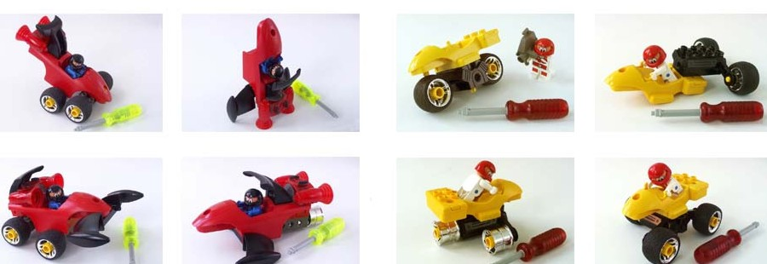
Different Racing Devices in play materials

After each new racing device has been developed and tested out in a mission a record is kept. The data file contains information about design, speed, controllability, acceleration and general features.

B.O.B.B:
- Go racing in the Premiere Challenge Tournament – Overcome the challenges and win the Trophy.
- Design your own spectacular racing devices, cars, motorcycles, choppers or even rockets by simply point and click on the modules you want to attach.
- Go on mission and race against your competitors Al and Adrian
- Learn about the different modules – what does what – and when to use the Turbo Booster
- Make a strategy for what racing device and modules that are needed to solve a mission

Target Market:

Boys in the age 4 –7, KidsPower buyers (world-wide launch) – Play Materials is not being launched under the LEGO Duplo Brand

ESP’s:
- Stimulation of creative inventions and testing them out.
- Explore the world through missions, figure out coherence between designs and environments – what fit together
- Get the adrenaline up pumping when exciting races and missions take place

Competitors Analysis / State of Market:

This pre-school market is mostly related towards educational products, whereas KidsPower challenge take its outset in being a fun action game with learning qualities embedded.

Target Platforms:

PC, PSX (II?)

