Stunt Bike Race

Components:

Pepper

The player will be in control of Pepper's Stunt Bike. The player will not be in control during in game cut scenes, that is, when the stunt Bike comes on screen at the start and drives off at the end.

Jumps/Obstacles

Landscape and object jumps are used to propel Pepper into the air, enabling him to perform stunts. The Jumps are also used to help Pepper clear obstacles along the course like trains, cars and rubble.

Turbo’s

The player can earn turbos by successfully performing stunts while in air. The turbo automatically executes upon impact with the ground, propelling Pepper forward in a short burst of speed.

Stunts

To gain extra points and turbos, the player can perform a large number of stunts, most of which while jumping. The scores range upwards, depending on the difficulty and length of a stunt.

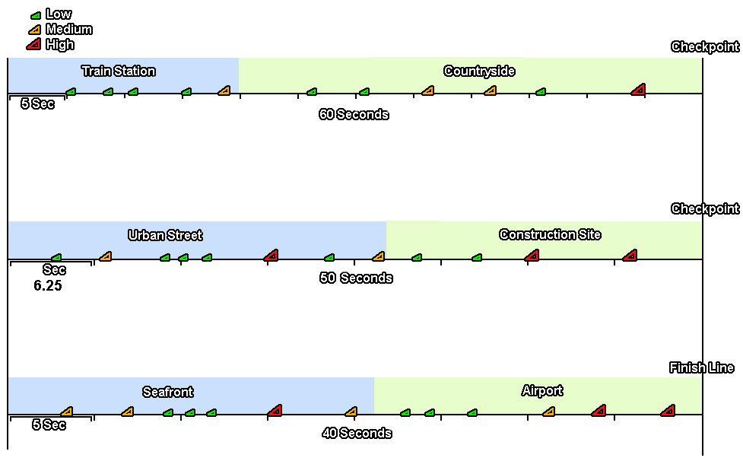
Stunt Bike Race Level One - Amateur Level

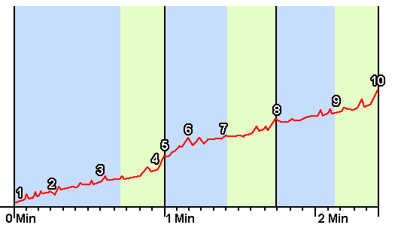
- The stunt bike will ride onto screen readying into position.
- The timer counts down to go.
- The game time starts to sound down.
- The player can start to accelerate the bike, and begin the race.

- The player has five seconds to generate speed and adjust to the simple controls.
- The first jump is small and very visual to help introduce the player.
- The first level starts off as a gentle introduction to the game, racing through busy and chaotic city streets.
- Most jumps are spaced out, with good run up and clear landings.
- The track it’s self is not too complex, leaving the player to concentrate more on handling the bike and adjusting to the physics.

- Throughout the course, the track design will start to introduce gradients, which will change the way the player handles the physics.
- Dropped throughout the course are a small number of medium jumps, allowing the player to propel further in the air.
- Pepper will leave the city streets arriving at a bustling train station.

4. | - Just before the end of the first section Pepper will ride over a large jump, which will propel him toward the end of the train station.
5. | - The checkpoint must be cleared before the timer runs out. Successfully reaching the checkpoint sees Pepper perform and amazing long jump over a passing train and onto the next section.
6. | - After landing from the jump, Pepper arrives in a hectic construction yard, full of ramps, walkways and builders.  - The game picks up slightly here, adding extra levels of gradient and more tightened jump distances.  - Throughout this course the medium jumps will feature more frequently allowing Pepper to score better stunts, but also upping the danger factor.
7. | - The Construction yard leads into the Airport, where Pepper travels through the grounds and hangers.  - This section features long straights cutup by two large jumps.  - The checkpoint for this section must be cleared before the time runs out. Successfully reaching the checkpoint sees Pepper perform an amazing jump over a plane, which is racing down the runway.
8. | - Landing from the jump put Pepper into a beautiful countryside, again featuring a more hectic level of gradients to drive through.  - This section features a more intense placement of jump, ranging from small to large. At this point the player must learn that some jumps taken at full speed, will put Pepper in a bad position for the next jump, leaving no room for run up. With this in mind, the player must learn to take some jumps a little lighter.  - The countryside leads out into a short sand dune run, before moving onto the seafront.
9. | - The Seafront features a long stretch of sand, before progressing into a pier.  - Pepper will perform a fairly large jump to reach the pier.  - After travelling down the pier, Pepper will reach one final large jump for the checkpoint.  - The final jump sees Pepper fly between the smoke funnels of a large cruiser ship.
10. | Level 1 complete.

Stunt Bike Theme Breakdown

Urban – 2115 Units

Background
City streets, office blocks, hotels, food outlets etc…

Pepper rides the trike on the roadway, jumping over obstacles like cars, trucks and roadworks.

Train Station – 1035 Units

Background
Train platform, train station, hills trees, road and stationary trains.

Pepper rides the trike up the platform, jumping over obstacles like luggage trucks and platform ramps.

Checkpoint
Pepper rides down a road and up the back of a dumper truck, (which has dropped its load☺) and over a crossing train.
See Sophies train crossing scene for a visual.

Construction Site – 1035 Units

Background
LEGO Construction Set, half-constructed office blocks, dirt hills, and construction vehicles.

Pepper rides the trike along a half build dirty roadway, up scaffolding along LEGO girders. Jumping over obstacles like digger arms, skips with wooden plank runners, angled large pipes, and dirt mounds.

Airport – 765 Units

Background
Hills, Trees, Airport building, control Tower, Hangers, warehouses, luggage trolleys, mobile stairs, planes, and fences.

Pepper rides the trike down a road onto the outdoor waiting area, and then to the runway. Jumping over mobile stairs, luggage piles, metal service ramps, and concrete slopes.

Checkpoint
Pepper rides up a hanger using it as a large jump then over a plane travelling down the runway.

Countryside – 945 Units

Background
Hills, Forrest, Trees, rocks, mountainside, valley, waterfall, and log cabin.

Pepper rides the trike across a dirt track down into a valley, over humpback bridges, and fallen trees. Jumping over dirt hills and natural formed jumps.

Seafront/Harbour – 855 Units

Background
Sand dunes, grass clumps, Beach houses, roadway, seafront buildings, hotels, food outlets, boats, piers, and cranes.

Pepper rides the trike across sandy dunes, onto a beach, upto a seafront road, onto the harbour then up a pier. Jumping over sand hills, and concrete steps.

Finish Line
Pepper rides up a steep set of steps (Like the ones you see in films to board ocean liners) and jumps onto a ship/boat which has left the port.

