Plane Chase Race

Components:

Pepper

The player will be in control of Pepper's plane. The player will not be in control during in-game cut scenes.

Brickster

The Brickster will feature within the second and third level. The Brickster will follow waypoints within the play area. The waypoints will tell the Brickster sprite where to 'fly'. The waypoints enable a degree of control of the Brickster, including slowing down and speeding up.

Henchmen

Personal Watercraft riders

The 'watercraft riders' are positioned at certain points on the first and third levels. They will be driving around on the water as the player tries to catch them with nets. They may release items, such as balloons, which may get in the way of the player.

Balloon Droppers

The 'balloon droppers' fly small planes and are positioned at certain points on the first and third levels. Their main aim is to drop balloons in front of the players plane. Popping the balloons will make the plane slow down. They may drop an amount of balloons before flying off screen and leaving the player. Their main task is to slow down Pepper.

Other Henchmen

The other henchmen will follow waypoints to do certain events, for example block an area so that Pepper needs to fly around them. These henchmen will have as much control as the Brickster.

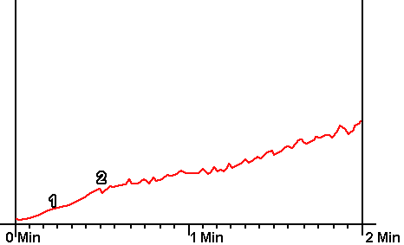
Level One – Amateur Level
- The plane will appear on the screen followed by the infomaniac explaining that the Henchmen are causing ruckus and Pepper must catch a certain amount before the plane will run out of fuel.
- The player will then gain control of the plane. The first level will start out as a gentle introduction to the game.
- The player will have an area that they can fly within; there will be no sudden sweeps as this beginning area is straight.
- Gradually from the narrow corridor that the player was previously in, the tracks in which the plane was constrained will open out allowing the player more room to manoeuvre within.
- There will be an amount of personal watercraft riders on the level. These will be driving around following waypoints.
- The player will release the nets to try and catch the require amount for passing this level.
- Balloon may be released to slow Pepper down.
- Pepper will also need to watch out for fuel, which may be hidden within balloons.
- The main constraint is that Pepper must watch his fuel, when the fuel gets too low, Pepper will be forced to land.
- If Pepper hasn't achieved the requirement for passing the level, to catch a certain amount of henchmen, the player will fail.

Level Two - Professional Level
The second level will be a challenge against the Brickster. Pepper will pick up a net to catch people that the Brickster is throwing from his plane.
Again, against a fuel time limit, Pepper will need to catch these people. Each person who isn't caught will be picked back up by flying henchmen and added to the Bricksters plane, to be thrown out again. After Pepper has caught a certain amount, the level is over.

Level Three - Super Star Level
The third level is essentially a sequential combination of the first and second levels. The player will have to catch a certain amount of henchmen before running out of fuel then need to deal with the Brickster and his people.

