Jons Subgame Ideas

Title: | Flying Carpet
Players: | 1 or 2
Controls: | No Use | Up | No Use |  |  |  |  | Decelerate
Controls: | Left |  | Right | No Use |  |  | Airbrake | 
 |  |  |  |  |  |  |  | 
Controls: | No Use | Down | No Use |  |  |  |  | Accelerate
Engine: | 3D, simple flight model
Game Type: | Flying Race
Story: | The evil Vizier has stolen the Caliphs best flying carpet and Pepper must catch him using the Caliphs other flying carpet before he escapes the city.
Gameplay: | Pepper has to fly better then the Vizier in a tag style race, where Pepper has to fly into the Vizier to win. If the Vizier reaches the city walls he wins.  Pepper will have a magic compass that will always point to where the Vizier is, so even if the Vizier is out of sight Pepper knows which way to fly.  Airbrakes: By pulling up the front of the carpet the flyers cause their carpets to slow down very rapidly. When airbraking is combined with a turn the carpet will perform a ‘handbrake’ turn.  The Carpets: The carpet flown by the Vizier is much better at turning then the carpet flown by Pepper. But due to the weight of the Vizier and his stolen goods his carpet is slower then Peppers.  To prevent the players from avoiding the obstacles the carpets cannot fly higher then the roofs of the buildings.  I expect the maximum flying speed to be in the region of 45mph. The narrowness of the streets will make this seem much faster.  Area: As the game is free form the landscape will not be of a linear course but closer to a small section of city similar to Midtown Madness.  Collisions: This is a racing game in a rather crowded environment collisions will be inevitable.  Shallow angle collisions will slow the flyer down as they scrap along the obstruction.  Head on collisions will make the flyer spin out of control for a couple of seconds.  Pedestrians will always manage to leap out of the way of low flying carpets.  The collision system should be very forgiving turning people away from the obstruction this will help to keep the game flowing.  As well as the buildings and the narrowness of some of the streets and alleys other obstacles would be washing lines, balconies, pedestrians camels and market stalls. |  |  |  | 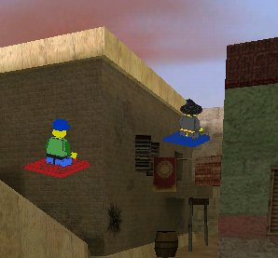  Sound  Ambient: This race is taking place in a living breathing city, so their should be almost a cacophony of ambient sound (donkeys braying, camels snorting and spitting, an Iman making the call to prayer, stall holders shouting out their wares etc). As Pepper and the Vizier race through the streets people and animals will be dodging out of the way and shouting at the two racers. There will also be plenty of people going WOW as the two racers fly past their windows.  Successful Actions: When Pepper is near the vizier he will be taunting Pepper.  Unsuccessful Actions: Collisions should have distinctive sounds, a muffled thump for head on collisions, a soft scraping sound as a carpet scrapes along a wall, and the twang as a washing line snaps. Long drawn out thumps and bumps with broken crockery if there is a crash into a market stall.  Neutral Actions:
High Score: | The time taken by Pepper in catching the Vizier.

Title: | Genie Battle
Players: | 1-2
Controls: | No Use | Up Menu | No Use |  |  |  |  | No Use
Controls: | No Use |  | No Use |  | No Use |  | Select Form from Menu
Controls: | No Use | Down Menu | No Use |  |  |  |  | No Use
Engine: | Single Screen
Game Type: | Visual Associations
Story: | The sorcerer has challenged you to a duel with genies. You must get your genie to choose the form that would beat the form chosen by the sorcerers genie.
Gameplay:  [Mouse]  Rabbit  Tea Cup | Whenever the enemy genie changes form, you will have a choice of forms for your genie to take. Choose the most appropriate forms for your genie and after a dozen shape changes you will have won.  Turn Based: The game is played in rounds and starts with the opponent’s genie taking its first form. The player then chooses his genies counter form.  Energy Bars: Both genies have an energy bar. If you choose the correct form to counter your opponent’s genie he will lose some energy. If you choose the wrong form for your genie then your genie loses some energy.  Timer: Each round is timed so the player is under a time constraint to choose a form. If the player doesn’t choose in time they lose the game.  Menu: The form choosing menu will only have three items in it so the player will not have to wade through 50 choices.  Animations: The genies should animate the way they defeat each others forms.  Two Player: In the two player mode of this game the player toss a coin to see who goes first (going first is a disadvantage). Then the players take turns to choose forms with both players able to damage each others genies. In the single player version only the players choices effect play and the computer cannot damage the players genie. |  |  | 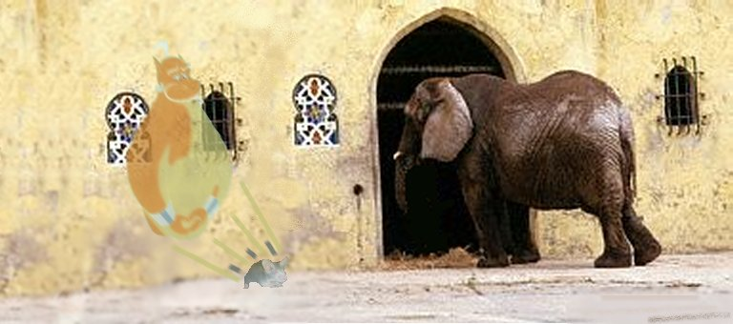  Sound  Ambient: The animations that are played as the genies battle will all require sounds to bring them alive.  Successful Actions: The opposing genie will call for mercy as your genies form beats his.  Unsuccessful Actions: The opposing genie will cackle whenever you choose the wrong form for your genie. Your genie should also say suitable phrases i.e. ‘Oh dear’ or ‘Oops’.  Neutral Actions: When a genie changes there should be a distinctive noise, e.g. Star Trek Transporter.  The players genie should have a friendly but pathetic voice like Dilberts in the Dilbert animations. While the opposing genie should have a deep booming film trailer style of voice.
High Score: | Energy level of your genie at the end of the battle.

Genie Battle continued...

Form | Counter Form A | Counter Form B
Elephant | Mouse | Sabre Tooth Tiger
Mouse | Cat | Owl
Cat | Dog | Bucket of Water
Dog | Collar | Flea
Collar | Knife | Scissors
Knife | Stone | Breast Plate
Stone | Pickaxe | Tree
Pickaxe | Woodworm
Woodworm | Woodpecker | Wasp
Woodpecker | Sparrowhawk | Cat
Sparrowhawk | Cuckoo
Cuckoo | Tree Snake | Cat
Tree Snake | Mongoose
Mongoose | Wolf
Wolf | Fire | Bear Trap
Fire | Bucket of Water | Kettle
Bucket of Water | Camel | Axe
Camel | Elephant
Sabre Tooth Tiger | Tar Pit
Tar Pit | Oil Derrick
Oil Derrick | Fire
Owl | Lantern
Lantern | Wind | Bucket of Water
Wind | Sail
Sail | Fire | Scissors
Flea | Oxpecker | Honey
Oxpecker | Sparrowhawk
Scissors | Stone
Breast Plate | Pickaxe
Tree | Axe | Elephant
Axe | Woodworm | Stone
Bear Trap | Mouse
Kettle | Teacup
Teacup | Bull
Bull | Red Blanket
Red Blanket | Scissors | Moth
Moth | Lantern | Spider
Spider | Cuckoo
Wasp | Smoke | Spider
Smoke | Chimney
Chimney | Wind
Honey | Bear
Bear | Bear Trap | Wasp

Genie Battle continued...

Animations

Elephant scares the camel; Elephant uproots the tree.
Mouse scares the elephant; Mouse triggers the bear trap safely.
Cat catches the mouse; Cat catches the woodpecker; Cat catches the cuckoo.
Dog chases the cat.
Collar controls the dog.
Knife cuts the collar.
Stone blunts the knife; Stone blunts the scissors.
Pickaxe breaks the stone; Pickaxe penetrates the breastplate.
Woodworm eats the pickaxe handle; Woodworm eats the axe handle.
Woodpecker eats the woodworm.
Sparrowhawk catches the woodpecker; Sparrowhawk catches the oxpecker.
Cuckoo lays egg in sparrowhawks nest; Cuckoo eats the spider.
Tree snake eats the cuckoos egg.
Mongoose catches the tree snake.
Wolf catches the mongoose.
Fire scares the wolf; Fire destroys the oil derrick; Fire burns the sail.
Bucket of water puts out the fire; Bucket of water soaks the cat; Bucket of water puts out the lantern.
Camel drinks the bucket of water.
Sabre tooth tiger pounces on the elephant.
Tar pit traps the sabre tooth tiger.
Oil derrick drains the tar pit.
Owl catches the mouse.
Lantern blinds the owl; Lantern attracts the moth.
Wind blows out the lantern; Wind blows down the chimney.
Sail fills with wind.
Flea bites the dog.
Oxpecker eats the flea.
Scissors cut the collar; Scissors cut the sail; Scissors cut the red blanket.
Breast plate stops the knife thrust.
Tree breaks the stone with its roots.
Axe cuts down the tree; Axe smashes a hole in the bucket of water.
Bear trap catches the wolf; Bear trap catches the bear.
Kettle uses the fire to boil.
Teacup is filled by the kettle.
Bull smashes the china teacup.
Red blanket distracts the bull.
Moth eats the red blanket making holes in it.
Spider catches the moth; Spider catches the wasp.
Wasp stings the bear; Wasp parasitises the woodworm.
Smoke stupefies the wasp.
Chimney contains the smoke.
Honey traps the flea.
Bear eats the honey.

Should wrong choices have their own animations?

Title: | White Water Rafting
Players: | 1-4
Controls: | No Use | No Use | No Use |  |  |  |  | Paddle
Controls: | Turn Left |  | Turn Right | No Use |  |  | Reverse Paddle
Controls: | No Use | No Use | No Use |  |  |  |  | Paddle Harder
Engine: | 3D Simple Boat Simulation
Game Type: | Obstacle Avoidance
Story: | Johnny Thunder has decided that the fastest way to get to China from Tibet is to raft down the river Yangtze. As the river falls from the Tibetan plateau to the Chinese plains it forms many rapids, Pepper and Johnny must negotiate these rapids.
Gameplay: | The rapids have many dangers, rocks, whirlpools, submerged boulders, waterfalls, and strong currents. Pepper and Johnny have to steer their raft past all of these obstacles. Sometimes they will need to paddle with the flow and sometimes against it.  Be careful not to allow the raft to capsize, or to be ripped by a rock and sink.  Rocks: Rocks rear up out of the water like broken teeth. When the raft hits a rock it will bounce off of the rock often turning as well, making subsequent navigation a little bit more difficult.  Whirlpools: The whirlpool spins the raft round and round, faster and faster until it spits the raft out in a random direction. If you are in the outer parts of a whirlpool, where the water is moving slowly you can paddle to safely.  Submerged boulders: The submerged boulder is difficult to spot, what you have to look for is a stationary wave. If you go over a submerged boulder it may rip the raft which will deflate and you will sink.  Waterfalls: Going over a waterfall will get you wet. The higher the waterfall the more chance you will have of capsizing.  Currents: Currents can be determined by the speed and heading of small surface waves. If you get caught by a strong current you will lose control of the raft. As most strong currents lead to waterfalls its not a good idea to let yourself get caught by them. The ride is never going to be smooth as there will always be some sort of current acting on the boat. Sometimes you will be pushed towards dangers and sometimes pushed away from them. We may need to model hydrodynamics, or we could put in simple attract and repel points.  Damage Bar: The raft has a damage bar and collisions with rocks and submerged boulders reduce the rafts health. Submerged boulders causes much more damage then hitting a rock.  Wetness Meter: This shows how wet Johnny and Pepper have got. The game is not failed if Pepper and Johnny are totally soaked, but only if the boat is destroyed. |  |  |  | 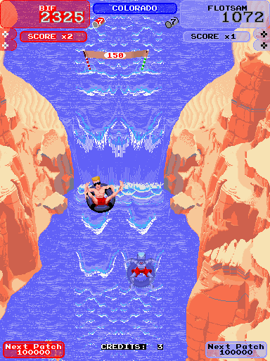  Sound  Ambient: Your on stretch of white water, there will be the sounds of rapid running water. Waterfalls deep thunder will be heard long before the waterfall can be seen.  Successful Actions: Johnny should be shouting encouragement throughout the subgame. We could have Johnny giving instructions these will need to be subtitled.  Unsuccessful Actions: Hitting a rock will produce a rubbery boing. Going over a submerged rock will produce a long drawn out rubbery scraping. Johnny will complain as he gets wet. With quite prolonged whinging if you go over the waterfall.  Neutral Actions: Oars will creak as you row, and the sounds of the blades may even be heard on the quieter stretches of the river.
High Score: | How dry Johnny and Pepper are at the end of the rapids.

Title: | Mountain Climbing
Players: | 1-4
Controls: | Direction | Direction | Direction |  |  |  |  | Left Hand
Controls: | Direction |  | Direction | Left Foot |  |  | Right Foot
Controls: | Direction | Direction | Direction |  |  |  |  | Right Hand
Engine: | 4 Way Scrolling
Game Type: | Platform
Story: | The final obstacle to reaching the Tibetan monastery is to climb a sheer cliff.
Gameplay: | The aim of the game is to climb up a cliff as fast as possible. Climbers move one handhold at a time testing each hold before putting their weight on it.  Holds: Each hold can only be occupied by a single limb. The holds are arranged so that there are a couple routes up the cliff face and only one dead end.  Movement: Press and hold the button for the limb you wish to move and then use the D-Pad to move that limb until it reaches a hold. When a limb gets close enough to a hold that wasn’t the one that the limb came from your limb will snap to it. You cannot continue moving that limb until you let go of the limb button. Then if you press the limb button again you can continue moving that limb. If a limb is nowhere near a hold and you let go of the limb button then the limb will return to its original hold.  Fatigue: Climbing is tiring and to increase tension Pepper will get fatigued while looking for new holds. While all the limbs are set the player will lose fatigue. If Pepper gets too fatigued while searching for a new hold he will immediately return to his old hold.  The player will be constantly planning ahead. Resting between changes of hold, and trying to make a hold change as rapidly as possible.  Bad Holds: Some of the holds are quite poor and the player will only be able to hold onto them for a short while. A bad hold will be visually represented by being outlined in red. When a player uses a bad hold it will fail in 30 seconds, a pie chart will appear next to the hold and will have an expanding segment in red showing the holds failure. When very close to failure say 5 seconds the pie chart will flash, so the player knows to do something. The routes up the cliff will require the player to use bad holds occasionally. In the multiplayer version of this subgame a player may use bad holds in a manner that will prevent the following players from ever getting up the cliff.  Automatic Failure: If there is no possible path up the cliff the game ends immediately informing the player that there is now no route up the cliff. |  |  |  | 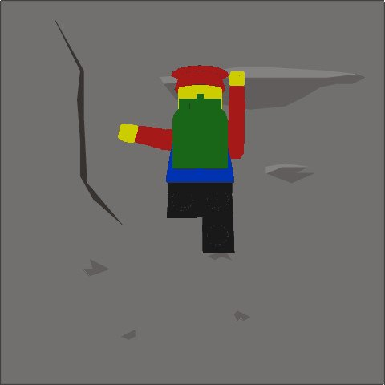  Sound  Ambient: The whistling of the wind should give the impression of loneliness and height. Eagles should be heard screeching in the distance.  Successful Actions: Pepper should be talking to himself as he keeps himself focused. E.G. ‘I can do it’ and ‘Don’t look down’.  Unsuccessful Actions: Pepper should exclaim whenever he fails to get a new hold, as anyone would hundreds of feet above ground who makes a mistake. We could include Pepper dislodging a stone and some time later have the sound of it hitting the ground to accent how high up Pepper is.  Neutral Actions:
High Score: | Time taken to scale the cliff.

Title: | Polo
Players: | 1-2
Controls: | Direction | Direction | Direction |  |  |  |  | No Use
Controls: | Direction |  | Direction | Tackle |  |  | Shoot
Controls: | Direction | Direction | Direction |  |  |  |  | Change Player
Engine: | 4 Way Scrolling
Game Type: | Team Game
Story: | Dynamo Tartars is playing Real Uighars at a game of polo but the Dynamo Tartars star player is ill, Pepper has been asked to take his place and help the Dynamo Tartars win the game.
Gameplay: | Polo as played by the Mongols is not a game for the gentry but is more of a Millwall, Wimbledon derby on horseback and armed with long handled mallets.  Arcade Action: This game should be fast and furious. A simple top down camera system. Game play like sensible soccer. There are only be four players to a side and there are no goalkeepers, just the goal posts. The player is controlling the whole team and the player will be taking control of whoever is nearest the ball. The game should last 5 minutes at the most.  Controls:  D-Pad – Character under the players control  movement direction. If the character under  the players control has the ball then they  will ‘dribble’ automatically.  When the player hits the A button to whack  the ball the D-Pad controls the direction in  which the ball is whacked.  B-Button – If you are approaching an opposing  player with the ball this will make you  tackle, all tackles will be successful.  A-Button – Whack the ball, this will be in the  direction that the D-Pad is being  pressed.  Right Shoulder Button when not in control of the  ball force a change in who you control to the  player nearest the ball.  Rules: There aren’t any, you cannot foul, force corners or throw ins, the ball will always be in play except when it is in the goal. Actually polo has plenty of rules mostly to do with safety, on the computer we don’t need to worry about horses getting hurt, so our virtual horses cannot come to harm.  Kick Off: This is similar to a rugby line out, both teams line up parallel to each other and the ball is rolled between the two teams, with a scramble by the players to get the ball. Only the character under the players control will try for the ball on the players side. Only one of the members of the opposing team will try to get the ball.  Physics: The ball will always stay on the ground. All of the players have identical abilities, so the ball will always travel the same distance (40 yards) when whacked. When dribbling the dribbling character will be slower then non-dribbling character. The ball when whacked will slow down as it rolls eventually coming to a stop. If you are within 10 yards of a whacked ball you will not be able to intercept it as it is travelling to fast, otherwise if you are in the path of the ball you will take control of it and begin dribbling with the ball.  Collisions: When the polo players collide they will slide against each other. All of the horses and riders have the same weight so they will all push each other to the same degree. If two players push each other in exactly opposite directions neither will move.  Pitch: The pitch is surrounded by low boards that stop the ball leaving play. The only gaps in the boards are the two goals. The pitch is 150 yards long and 80 yards wide, there is a halfway line, the goals are only 8 yards wide. |  |  |  | 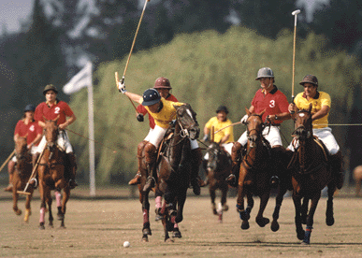  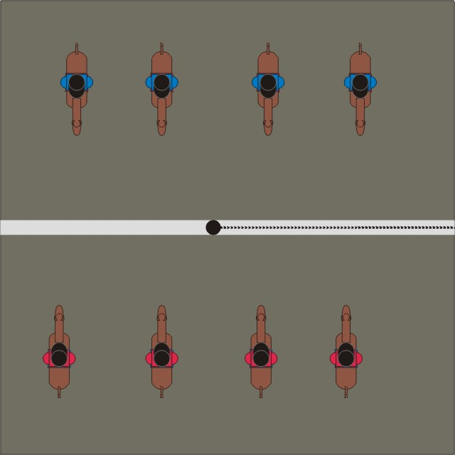  Polo Kick Off  Sound  Ambient: This is a match in front of a crowd of cheering Mongols so their should be constant crowd noise.  Successful Actions: As the action on pitch gets more exciting, successful tackles, proximity to the goals, shots on goal the crowd should get even more excited.  Unsuccessful Actions:  Neutral Actions: Whenever the ball is struck their should be a distinctive thock, as a wooden mallet hits a wooden ball. The horses hooves should thud into the turf. Horses should whinny and neigh especially during tackles.
High Score: | Scoreline at the end of the match.

Title: | Mounted Archery
Players: | 1-4
Controls: | Aim | Aim | Aim |  |  |  |  | No Use
Controls: | Aim |  | Aim | No Use |  |  | Fire
Controls: | Aim | Aim | Aim |  |  |  |  | No Use
Engine: | Sideways Scrolling
Game Type: | Operation Wolf Shooter
Story: | At the court of Kublaih Khan they are having a tourney. One of the events is archery, on horseback. The Khan has ‘invited’ Pepper to take part.
Gameplay: | As you gallop down the field you have to shoot as many of the targets as possible. You are moving relative to the targets and have to be able to aim quickly.  Horses Motion: As the horse runs down the field there is some up and down movement as well as the steady left to right motion.  Aiming: The player has to correct his aim to take into account of the horses motion.  Arrow Indicator: This shows the players reloading progress as he fires, and then draws another arrow. Not only will Pepper be visible at the bottom of the screen drawing the bow, but the cursor will be red when you are reloading, changing to orange to show that you are almost ready to fire, and will be green when you can shoot.  Targets: At the beginning of the course the targets are big and widely spaced so if the player misses they will have enough time to shoot again at the target. As the course progresses the number of targets increases and they get smaller. At the end of the course if the player misses a target he will not have enough time to shoot at that target again.  Course Indicator: This is a simple bar that show how far down the field the player has got. |  |  |  | 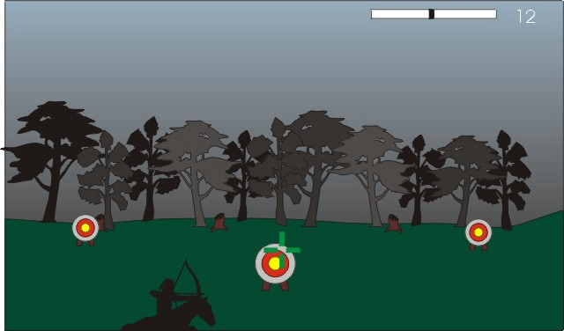  Sound  Ambient: As the horse runs down the field its hooves and breathing would be heard.  Successful Actions: Hitting a target will make a solid thump, followed by the crowd cheering.  Unsuccessful Actions: Missing a target and the watching crowd will sigh.  Neutral Actions: As Pepper draws the bow it will creak. When Pepper releases an arrow the bow string will twang. Arrows in flight will whoosh through the air.
High Score: | Targets hit.

Title: | Hide and Seek
Players: | 1
Controls: | No Use | Forwards | No Use |  |  |  |  | No Use
Controls: | Turn Left |  | Turn Right | Jump |  |  | Use Item
Controls: | No Use | Backwards | No Use |  |  |  |  | Jump
Engine: | 3D
Game Type: | Platformer with object interaction.
Story: | The Emperor has shown Pepper around his palace and then challenged Pepper to a game of hide and seek with the Emperor and his courtiers.
Gameplay: | When you meet the Emperor of China he shows you around his palace and then invites you to join him in a game of hide and seek. You have been shown the palace, so you must try and remember all of the possible hiding places you have passed.  Then run around the palace as quickly as you can and look into all of the hiding places. You will also need to jump up onto the furniture to get to some of the higher hiding places.  Environment: The Palace in this subgame is the same Palace found in the main world engine. By closing doors and gates the player will be kept in the subgame area. The area for hide and seek would include the Throne Room, the Emperors Bedroom, the Kitchen, an enclosed Garden and the Dining Hall.  Hiding Places: Behind floor length drapes, under the bed, in the canopy of the bed, in a large vase, up a tree, down the well, in the wardrobe, in a storage jar, in a cupboard, in a cauldron, behind some sacks, behind a hedge and under the throne. The people hiding will not move from one hiding place to another. Each time the game is played different hiding places are used, there are more hiding places then people playing the game so in each game several of the hiding places will be empty, and different places will be empty in each game.  Interaction: Pepper can run up to object and press the use button, Pepper will then perform an action appropriate to that item, for example pulling the drapes aside, or opening a cupboard.  The Start: Being the searcher Pepper has to close his eyes and count to one hundred before going to look for the hiders.  Timer: This game will be limited to at most 3 minutes so the player doesn’t get frustrated by wondering around for ages not finding that last elusive person. |  |  |  | 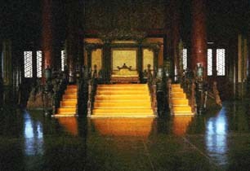  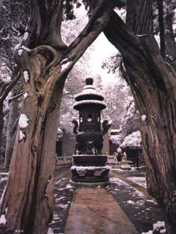  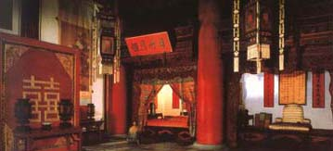
Gameplay: | Sound  Ambient: When Pepper has his eyes closed, and is counting to one hundred, you will hear in the background, footsteps, whispering and doors creaking. The direction and intensity of these sounds are accurate to the direction and distance that the person making those sounds are. This could include some one talking and a door being shut and the talking becoming muffled, showing that that person is in an adjacent room to Pepper. We will hear Pepper quietly counting to a hundred and then calling ‘coming ready or not’.  Successful Actions: When Pepper goes searching the other players could whisper ‘Shush he’s coming’ or similar when Pepper gets near to their hiding place.  Unsuccessful Actions:  Neutral Actions:
High Score: | Number of people found.

Title: | Camel-Train (Nibbler)
Players: | 1
Controls: | No Use | Up | No Use |  |  |  |  | No Use
Controls: | Left |  | Right | No Use |  |  | No Use
Controls: | No Use | Down | No Use |  |  |  |  | No Use
Engine: | Single Screen
Game Type: | Maze
Story: | The camel train Pepper and Johnny are with have made camp, when a sandstorm blows up, Pepper has to collect all of the camels together...
Gameplay: | The aim of the game is to collect all of the camels together without getting trapped by the camels.  Tail: Each time Pepper finds a camel it will grab the tail of the last camel and follow it. Each camel is as long as the width between the obstacles on the level. If Pepper has two camels behind him they will be two ‘corridor’ widths long. The trail of camels behind Pepper is flexible, see fig 1. If Pepper boxes himself in with the camels by crossing the path of the trail of camels he must start this subgame all over again.  Movement: Pepper must always go forward, and can only change direction at a junction (camels are very difficult to order about). Otherwise Pepper will follow the walls. When you come to a junction press the D-Pad direction for the direction you want Pepper to go in. See figure 2. If Pepper comes to a T-junction head on he will stop at the junction and wait to be told which direction to go. If Pepper comes to a corner he will just tun the corner  Timer: There is a timer starts at 90 and counts down, if the timer reaches zero Pepper has failed. The timer counts down slowly (1 a second) while Pepper is finding camels, but if he doesn’t found a camel for 4 seconds the timer speeds up and the count down becomes a blur. Say counting down four times faster. The timer colour starts off gold, changes to silver at 60, then changes to bronze at 30, and if the timer reaches zero the player fails. |  |  |  | 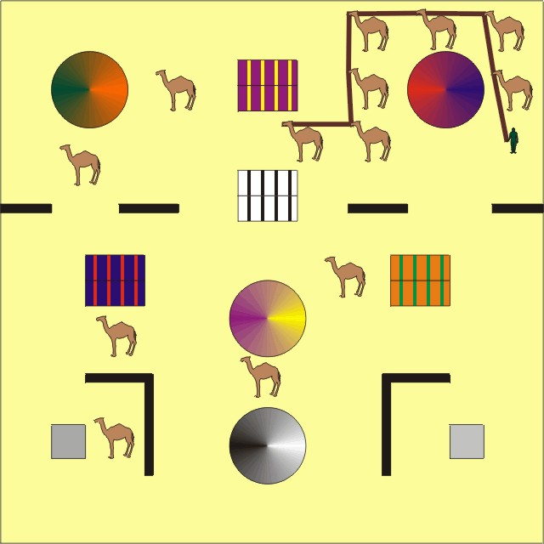  fig 1.  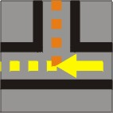  fig 2.  If the player presses up at this point Pepper will start going up (orange dotted line). Other wise Pepper continues towards the left (yellow dotted line). Pressing right will NOT reverse Peppers direction. Pressing down will have no effect due to the wall, and pressing left has no effect as you were already going in that direction.
Gameplay: | Sound  Ambient: The counter should be heard ticking in the background so the player will be able to hear the counter speed up if he has not found a camel for a long time.  Successful Actions: As Pepper finds the camels they will snort and grunt at each other.  Unsuccessful Actions:  Neutral Actions:
High Score: | Time taken to collect all of the bricks.

Title: | Memory (Wacko)
Players: | 1
Controls: | No Use | Forward | No Use |  |  |  |  | No Use
Controls: | Left |  | Right | No Use |  |  | Open Box
Controls: | No Use | Backwards | No Use |  |  |  |  | No Use
Engine: | Single Screen
Game Type: | Memory Puzzle
Story: | The Sultan has moved his menagerie to his summer palace, unfortunately none of the boxes that the animals were moved in had name tags. Pepper must sort out the animals so that they are reunited with their mates.
Gameplay: | Each animal is in a separate box. Pepper must match each pair of animals up. Once Pepper has found a pair the zoo keepers will take those animals to their cage.  Environment: The game is set in a menagerie which is a small open air zoo. Outside of the playing area are the cages for the animals. While the playing area is a large courtyard with twelve wooden boxes (containing the animals) in it.  Camera: The players viewpoint is from above, with all of the playing area visible all of the time.  Animals: Tigers, Pandas, Warthogs, Crocodiles, Ostriches and Zebras. Only six pairs to match up.  Making a choice: Pepper runs up to a box and opens it using the A-Button. That box will stay open with the animal displayed until Pepper opens a second box. When Pepper opens the second box if the animals match the animals are taken to their cage and those two boxes are removed. If the animals are different the second box will be open for a few seconds so we can see what animal was inside, before the first and second boxes are shut again for Pepper to start the choosing process all over again.  Expansion: The number of different animal types could be increased. The sizes of the boxes could reflect the sizes of the animals, so the two huge boxes hold the elephants and the two tiny boxes have butterflies (probably need an automatic magnifying glass for the smaller animals). |  |  |  | 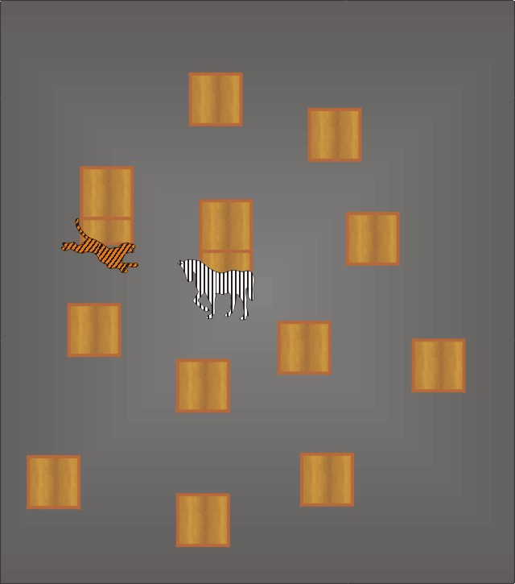
Gameplay: | Sound  Ambient: When a box is opened the animal inside will make noises appropriate to what they are.  Successful Actions: The menagerie keepers will shout hurrah and then they take the matched animals to their cages.  Unsuccessful Actions: The menagerie keepers will sigh and tell you that the animals don’t match.  Neutral Actions: As a box is opened the wooden door will creak.  Sound: When a box is opened that animal will make noises appropriate to them.
High Score: | Time taken to match all of the animals.

Title: | Crystal Patterns (Simon Says)
Players: | 1
Controls: | No Use | Top Crystal | No Use |  |  |  |  | No Use
Controls: | Left Crystal |  | Right Crystal | No Use |  |  | No Use
Controls: | No Use | Bottom Crystal | No Use |  |  |  |  | No Use
Engine: | Single Screen
Game Type: | Memory
Story: | Pepper has got locked into Ali Babas cave. The words open sesame will only open the cave mouth if spoken from outside. To open the cave from the inside you have to tap the crystals in the correct order.
Gameplay: | Game: The crystals will play a pattern and then Pepper must repeat that pattern. Each time Pepper gets the pattern correct the crystals will add an extra bit to the pattern.  Winning: If Pepper gets the pattern that is 7 items long, then the cave will open. You can continue playing the crystals until you get a pattern wrong for a higher score.  Crystals: The crystals are different colours. When a crystal is tapped it glows briefly and emits a clear musical note. When showing the player in which order to tap the crystals they also glow and play their note. This should aid the player in remembering which crystal played when. The crystals should be strong primary colours such as red, green, blue and yellow. The notes the crystals play should be chosen that in whatever order they are played they will not be discordant.  Example Pattern:  left, left  left, left, right  left, left, right, up  left, left, right, up, right  left, left, right, up, right, down  left, left, right, up, right, down, down |  |  |  | 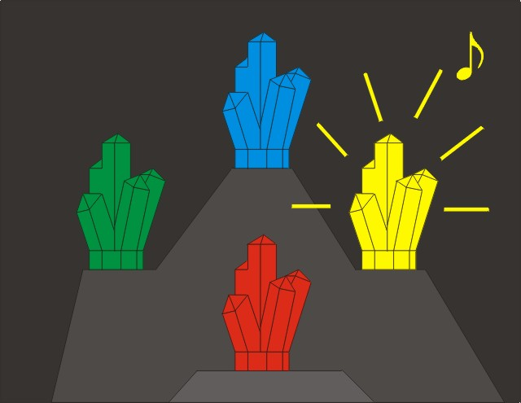  Sound  Ambient: You are in a cave so in the background would be the faint dripping of water. Also small animals should be heard scurrying about, and there would be the squeaking of bats.  Successful Actions:  Unsuccessful Actions:  Neutral Actions: The crystals when playing make clear musical tones.
High Score: | Length of pattern reached.

Title: | Knight Moves (Shah)
Players: | 1
Controls: | No Use | Make Move | No Use |  |  |  |  | No Use
Controls: | Move Selection Anti-Clockwise |  | Move Selection Clockwise |  | Wind up Clockwork |  | Wind up Clockwork
Controls: | No Use | No Use | No Use |  |  |  |  | No Use
Engine: | Single Screen
Game Type: | Chess based puzzle
Story: | Trapped in the sorcerers castle Pepper is trying to escape. He comes to chasm with a giant chess board across it. Many of the squares are missing and there is only a knights piece on this side of the chasm. The knight offers to carry Pepper across the chasm.
Gameplay: | Using the unique method that the knight uses to move cross the chessboard to reach the other side in safety.  Environment: The chess board is 3D with the squares at different heights to each other. Water is slowly rising and will inundate the lower squares so the Knight has to get to high ground quickly.  The Knight: The player is shown how a knight moves and is reminded that the knight can jump over obstacles. The knight is a marvellous clockwork contraption and needs winding up for every move, for some button bashing action.  Movement: The player is allowed to backtrack, and cannot make a move that will land in water.  Routes: There are several routes across the board so the player should not get stuck.  Bonus points are awarded for rescuing the damsel.  Clockwork Winding Meter: This shows how well wound up the clockwork knights mechanism is, green shows that the knight can jump over obstacles, orange shows that the knight can move but can’t jump, and red shows that the knight can’t move.  Dragon: There is a dragon flying about the chess board and if the knight stays in position for too long the dragon will attack the knight, causing a considerable delay to the knights progress across the board. The dragon attacks if the knight hasn’t moved for 5 seconds. |  |  | 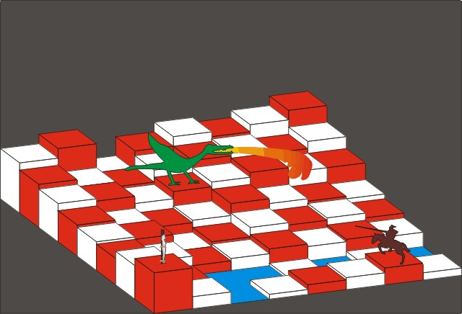  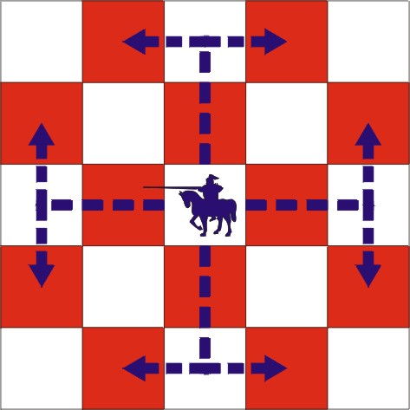  How a Knight moves.  Sound  Ambient: The water gurgles as it rises. The wingbeats of the dragon will be heard as it flies around the board. When the dragon attack it will dive at the knight emitting a scream similar to a dive bombers.  Successful Actions: The damsel will thank you profusely if you rescue her. Until she is rescued the damsel will call for help.  Unsuccessful Actions: If the dragon catches the knight, there would be a lot of noise as the knight beats at the dragon with his sword. The screech of the dragons claws against the metal skin of the clockwork knight. As well as the roar whenever the dragon belches flame.  Neutral Actions: Winding up a clockwork mechanism makes a distinctive rapid clicking.
High Score: | Time taken.

Title: | The Vortex
Players: | 1-4
Controls: | No Use | No Use | No Use |  |  |  |  | No Use
Controls: | Move Selection Anti – Clockwise |  | Move Selection Clockwise | No Use |  |  | Confirm Selection
Controls: | No Use | No Use | No Use |  |  |  |  | No Use
Engine: | Single Screen
Game Type: | Puzzle
Story: | Pepper still trapped in the sorcerers castle comes to another chasm. The crossing here is a hexagonal lattice and a sign detailing the rules for safely crossing the chasm.
Gameplay: | Rules: The Vortex moves first.  If you move into the vortex you lose.  The vortex is invisible.  The vortex cannot move into you.  Neither you or the vortex can move back.  GOOD LUCK  The Vortex: If the player moves into the vortex they are teleported back to the start. At the start of the game the vortex is shown on the single pad at the far end of the chasm.  The first person across the chasm wins.  Turns: Each player selects his move, once all of the players have selected their moves the moves happen simultaneously. Then the vortex moves. Then the players select their moves again, and so on.  Sound  Ambient:  Successful Actions:  Unsuccessful Actions: When a player is teleported back to the start we can make it sound like Star Trek Transporters.  Neutral Actions: When the vortex moves it growls to its new position. This sound comes from everywhere so you cant use sound to try to work out where the vortex is. |  |  |  | 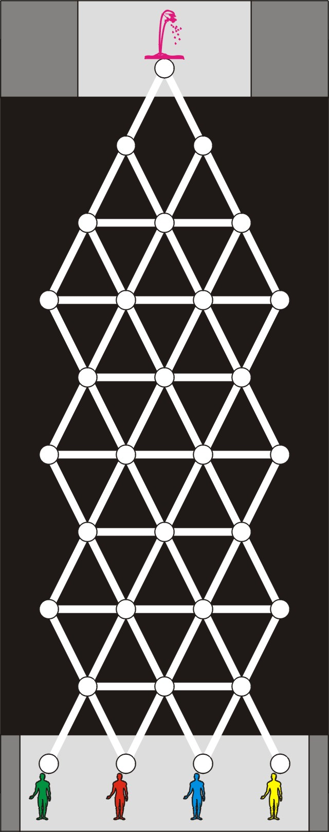
High Score: | Not applicable.

Title: | Saddle Up (The Giant Hand) Alternate
Players: | 1
Controls: | Cursor | Cursor | Cursor |  |  |  |  | No Use
Controls: | Cursor |  | Cursor | No Use |  |  | Throw Pizza
Controls: | Cursor | Cursor | Cursor |  |  |  |  | No Use
Engine: | Single Screen
Game Type: | Platformer boss fight
Story: | Pepper and Johnny have been trapped in a room with an enraged giant mechanical hand.
Gameplay: | Aim: Pepper must prevent the giant hand from catching Johnny, while Johnny retrieves the pieces of his broken gun. When Johnny has reassembled his gun he will be able to shoot out the lock on the door to the room so that Pepper and Johnny can escape.  Peppers Job: Pepper has to throw pizzas at the giant hand. While the giant hand is scuttling a pizza will slow it down slightly. But if the hand has raised itself ready to attack Johnny a pizza hit will knock the hand onto its back delaying it considerably. Pepper will have a cross hair showing where his pizza will go to help the player aim. Hitting Johnny with a pizza will slow Johnny down.  Pizza Supply: Pepper has an infinite number of pizzas.  Environment: The room is open with a low balcony where Pepper is flinging his pizzas from.  Johnnys Gun: This has been broken into 3 pieces and the 6 bullets have fallen out. These are scattered around the floor of the room, and Johnny must collect all pieces of the gun and the 6 bullets.  The Giant Hand: The hand is faster then Johnny. The hand attacks by rotating back onto the heel of the hand and raising its fingers, before dropping forward onto Johnny. This is when the hand is most vulnerable to pizza hits. If the hand is struck by pizzas while it is in the attacking position it will fall onto its back. When the hand is toppled onto its back it will take several seconds to get back upright. Once the hand has knocked Johnny flat it will tickle him. |  |  |  | 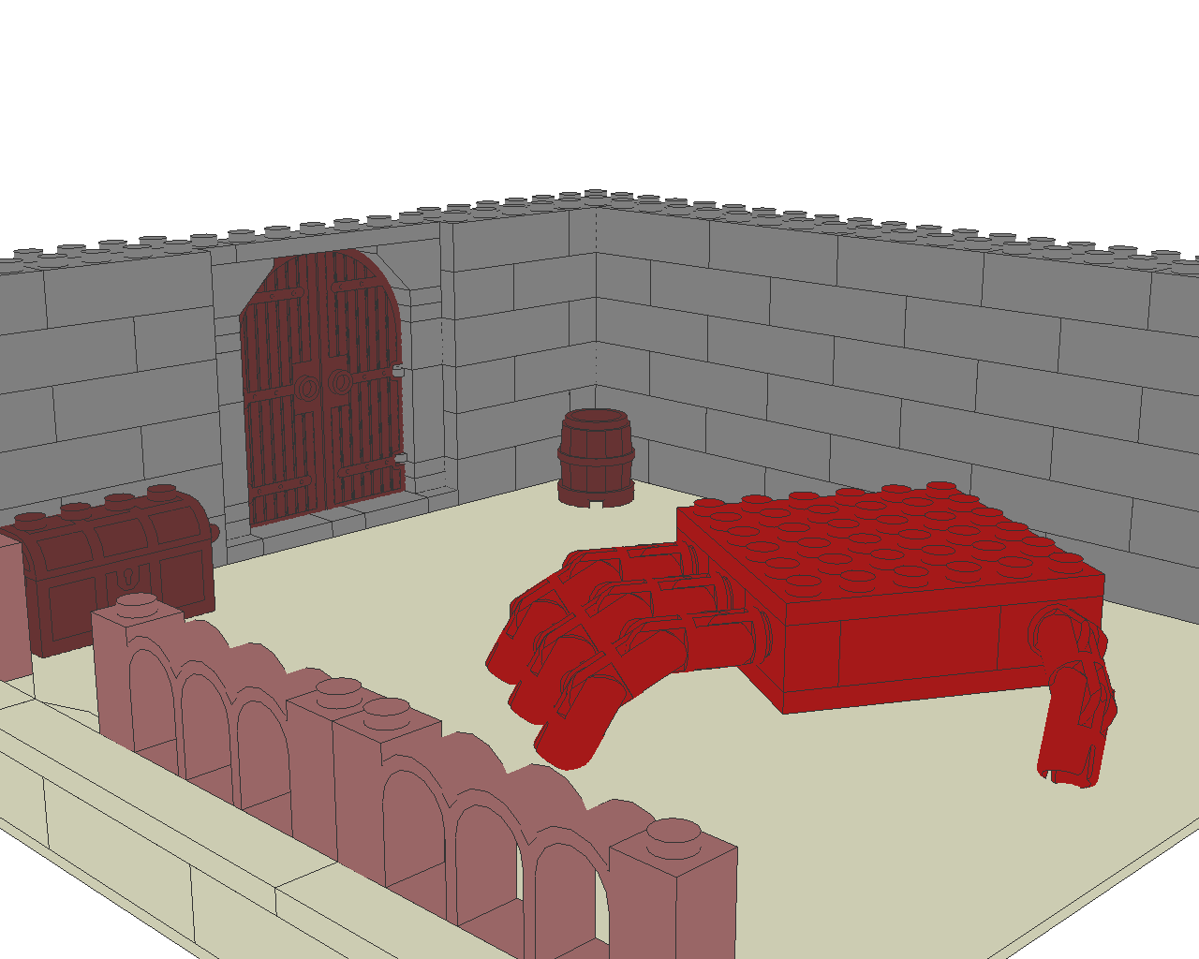  Giant Hand Normal  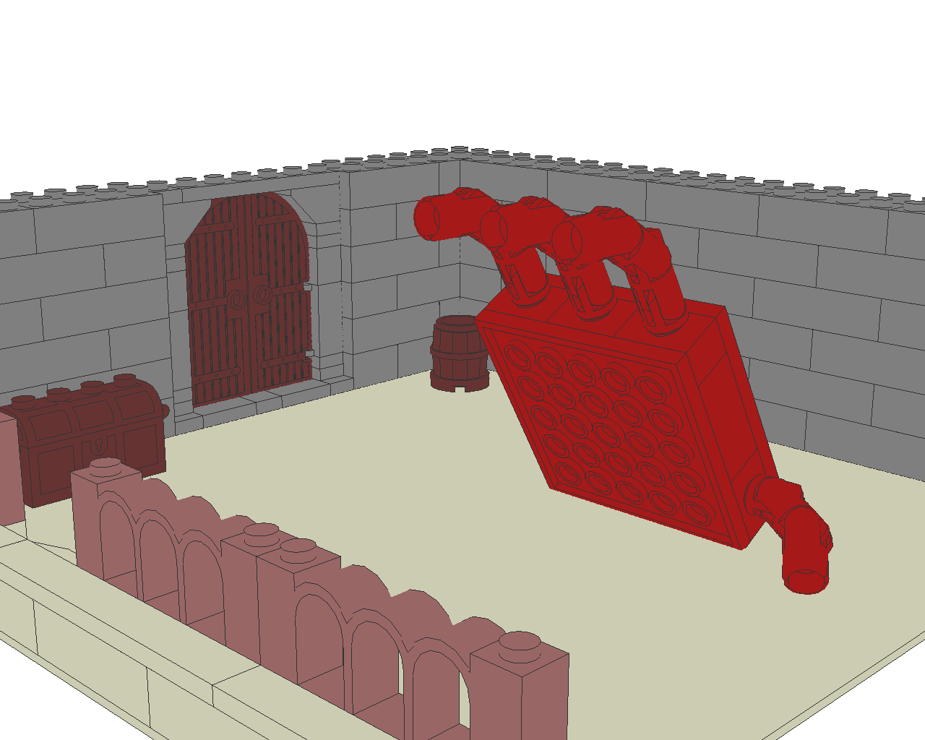  Giant Hand Attacking
Gameplay: | Sound  Ambient: The hand is made from a wooden frame, covered in leather and stuffed with horse hair, so while it moves around it should creak.  Successful Actions: Hitting the hand while it is in the attacking position will get the splat followed by a big crash as the hand topples onto its back. At the end of the game Johnny will shoot the lock out followed by him kicking the door open.  Unsuccessful Actions: If you miss the hand with a pizza it will make no noise. If you hit Johnny with a pizza it will splat, followed by Johnny moaning at Pepper. While Johnny is being tickled he will laugh, cry and beg for mercy.  Neutral Actions: Hitting the hand with a pizza while its scuttling will produce a satisfying splat.
High Score: | Number of pizzas thrown, less pizzas used the better Peppers ranking.

Title: | Roc’s Away
Players: | 1
Controls: | No Use | No Use | No Use |  |  |  |  | No Use
Controls: | Steer Left |  | Steer Right | No Use |  |  | No Use
Controls: | No Use | No Use | No Use |  |  |  |  | No Use
Engine: | Forward Scrolling
Game Type: | Obstacle avoidance.
Story: | The ship Pepper and Johnny have taken to India has disturbed a pair of Roc’s. The Roc’s are trying to sink the ship by dropping boulders onto it. The first boulder knocked out the guy at the wheel so Johnny and Pepper have taken over.
Gameplay: | Steer left and right to avoid the boulders dropped by the two Roc’s. Watch out for the reefs as well.  Damage Bar: The ship has a damage bar, each time the ship is hit by a reef or a dropped boulder it will suffer damage. Once the ships damage bar reaches zero it sinks.  Distance Indicator: There should be an indicator showing how far the ship has got from the rocs island, with the far end showing the safe distance.  Reefs: Reefs appear on the horizon and as the ship sails the reefs will get closer. If you hit a reef the ship will suffer substantial damage. As the distance from the rocs island increases the number of reefs increases.  Rocs: The rocs fly above the ship in figure of eight’s dropping eggs randomly. Once a roc has dropped a boulder it will fly off screen to get another boulder and will reappear shortly. As the distance from the rocs island increases it takes them longer to get new boulders. The rocs cast shadows on the sea so the player can more easily gauge where the rocs are.  Dropped Eggs: The eggs dropped by the rocs are less damaging to the ship than the reefs unless the egg hits the ship dead centre. When an egg is dropped its shadow will appear on the surface of the sea so that the player can see the aiming point and dodge better. The eggs fall quite slowly so that the player will have enough time to dodge.  Ship: The ship is an Arab dhow, while more manoeuvrable then European ships it does still take a while to turn. With the ship turning slowly and the eggs falling slowly the game will be less frantic but will have moments of terrible inevitability. |  |  |  | 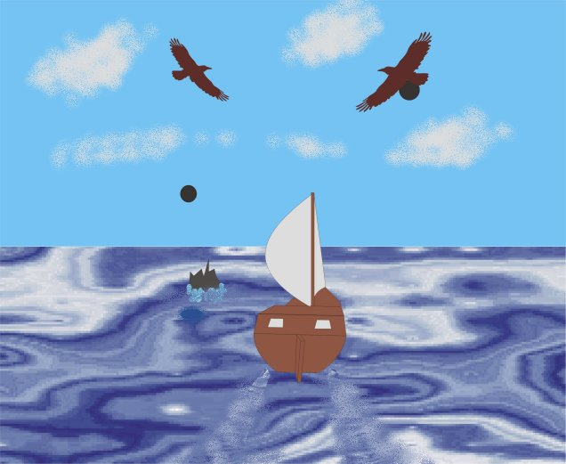  Sound  Ambient: The ship creaks, waves lap against the hull and seagulls scream.  Successful Actions: The crew cheer every time a Rocs egg misses the boat.  Unsuccessful Actions: Glancing egg hits on the ship would have a much less impressive crunch then direct egg hits. When the ship hits a reef there should be a prolonged grinding as the ship takes damage.  Neutral Actions: The Rocs will caw loudly whenever they drop an egg. The egg should whistle as it drops like a bombs falling whistle.
High Score: | Level of damage the ship has at the end of the course.

