Title: | Hide and Seek
Players: | 1
Controls: | No Use | Forwards | No Use |  |  |  |  | No Use
Controls: | Turn Left |  | Turn Right | Jump |  |  | Use Item | 
 |  |  |  |  |  |  |  | 
Controls: | No Use | Backwards | No Use |  |  |  |  | Jump
Engine: | 3D
Game Type: | Platformer with object interaction.
Story: | The Emperor has shown Pepper around his palace and then challenged Pepper to a game of hide and seek with the Emperor and his courtiers.
Gameplay: | When you meet the Emperor of China he shows you around his palace and then invites you to join him in a game of hide and seek. You have been shown the palace, so you must try and remember all of the possible hiding places you have passed.  Then run around the palace as quickly as you can and look into all of the hiding places. You will also need to jump up onto the furniture to get to some of the higher hiding places.  Environment: The Palace in this subgame is the same Palace found in the main world engine. By closing doors and gates the player will be kept in the subgame area. The area for hide and seek would include the Throne Room, the Emperors Bedroom, the Kitchen, an enclosed Garden and the Dining Hall.  Hiding Places: Behind floor length drapes, under the bed, in the canopy of the bed, in a large vase, up a tree, down the well, in the wardrobe, in a storage jar, in a cupboard, in a cauldron, behind some sacks, behind a hedge and under the throne. The people hiding will not move from one hiding place to another. Each time the game is played different hiding places are used, there are more hiding places then people playing the game so in each game several of the hiding places will be empty, and different places will be empty in each game.  Interaction: Pepper can run up to object and press the use button, Pepper will then perform an action appropriate to that item, for example pulling the drapes aside, or opening a cupboard.  The Start: Being the searcher Pepper has to close his eyes and count to one hundred before going to look for the hiders.  Timer: This game will be limited to at most 3 minutes so the player doesn’t get frustrated by wondering around for ages not finding that last elusive person. |  |  |  | 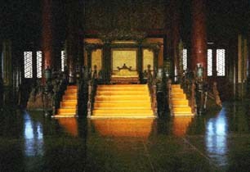  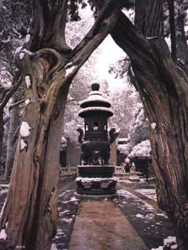  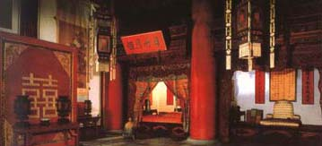
Gameplay: | Sound  Ambient: When Pepper has his eyes closed, and is counting to one hundred, you will hear in the background, footsteps, whispering and doors creaking. The direction and intensity of these sounds are accurate to the direction and distance that the person making those sounds are. This could include some one talking and a door being shut and the talking becoming muffled, showing that that person is in an adjacent room to Pepper. We will hear Pepper quietly counting to a hundred and then calling ‘coming ready or not’.  Successful Actions: When Pepper goes searching the other players could whisper ‘Shush he’s coming’ or similar when Pepper gets near to their hiding place.  Unsuccessful Actions:  Neutral Actions:
High Score: | Number of people found.

Subgame locations
List of items that fit into the locations within the subgame.

Kitchen (Pages 131 - 136 Insight Guide to China)
Cooker
Sink
Preparation table
Fridge
Freezer
Tool Rack
Cupboards
Hatchet
Knifes
Forks
Spoons
Bowls
Plates
Chop Sticks
Poultry
Pork
Meat Hanging Rack
Pans
Woks
Chopping Board
Shelves
Pots of Herbs and spices
Double swing doors
White aprons
Glasses
Buckets of miscellaneous foods
Weave Baskets containing poultry
Tiled floor
White walls
Fish
Extractor fan
Chimney
Chefs Hat

Throne Room
Throne
Stone Pillars
Flowers
Benches
Steps
Wooden flap windows
Tiled floors
Rugs
Ornamental pillars
Vases
Warrior uniforms
Tiled ceilings
Large red double doors
Statues

Emperors Bedroom
Four poster bed
Clothes chest
Changing partition
Dresser with mirror
Rug
Tiled floor
Draws
Wardrobe
Mannequin
Hat stand
Wooden Balcony
Plants
Vases
Chair
Buddhist rosary beads

Bathroom
Large Iron Bath
Tiled floor
Sink
Toilet
Cupboard
Towel rack

Corridors
Pillars
Ornamental Pillars
Statues
Large vases
Benches
Tiled floor
Wooden flap windows

Dining Hall
Large table
Chairs
Portraits
Statues
Chandeliers
Large double doors
Warrior suited mannequins
Large balcony over courtyard

Laundry Room
Washing machines
Dryers
Clothes lines
Clothes
Baskets
Flat press iron
Shelves
Towels

Storeroom
Shelves
Boxes
Crates
Stacks of Paper

Reception
Benches
Fountain
Stair case
Statues
Portraits
Patterned tiled floor
Pillars

Emperors Jewellery Room
Ornamental Pillars
Pillars
Warrior Suits
Golden statues
Statues
Books
Scrolls

Library
Shelves
Books
Scrolls
Tables
Chairs
Pedestals

