Car Chase

Components:

Pepper

The player will be in control of Pepper's car. The player will not be in control during in-game cut scenes, that is, when the car comes out of the truck at the beginning of the level.

Brickster

The Brickster will be placed at a certain point on the map. Once the player reaches a point within the Brickster's radius, the Brickster will start following waypoints. These waypoints tell the sprite where to 'drive'. The waypoints enable a degree of control of the Brickster, including swerving, driving into stationary objects (i.e. walls, buildings) and in-game set pieces, for example, a particular car would be in the path of the Brickster and a certain event would happen.

Henchmen

- Oil slickers

The 'oil slickers' are positioned at certain points on the level, their main aim is to ram Pepper's car or to drive in front of the players car and drop an oil slick. They can do either of these objectives, an amount of times before driving off screen. Their main task is to slow down Pepper.

- Other henchmen

The other henchmen will follow waypoints to do certain events, for example block the road so that Pepper needs to drive around them. These henchmen will have as much control as the Brickster.

AI cars

The AI cars make up the rest of the traffic on the roads. Although not smart enough to overtake each other, they will stop at red lights. When the player/henchmen/Brickster hits an AI car, they will be stunned for an amount of time and then resume their particular journey.

Lane Limiters

Lane limiters are use in conjunction with the cones. A lane limiter will simply block a particular lane forcing the player to drive around. Hitting a lane limiter will be like hitting a normal collision wall.

Cones

Cones are standard traffic cones. The player will be able to hit them and they will bounce away from the player. The can be used to mark a particular lane or dead end road.

Turbo’s

The player can collect up to three turbos, which will be placed, on the road to pick up. The player can not collect more than three even if they drive over another turbo. At any point, the player can choose to use a turbo by pressing R shoulder button. The means that the use of such turbos may require strategy from the player.
Car Chase Level one - Amateur Level

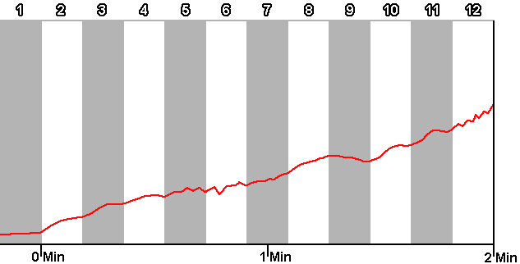

- The truck comes on to the screen and the player's car will drive out.

- The Infomaniac explains that the Brickster is some distance away but will be at a junction within a time period.

- The time counts down starting at that time. This gives the player something to aim for.

- They may not know where the junction is but they know how long they have to get there.

- The player will then gain control of the car.

- The first level starts off as a gentle introduction to the game.

- The player will have just the car on the multiple laned road.

- There will be no/light traffic.

- The road will be straight.

- This starts out like this so that the player can begin to learn about the handling of the car.

- The first corner may throw the player and they then may slide out, missing the corner but a well placed sand bank will stop the player so that they can get back onto the road and continue play.

- The next corner and proceeding corners after, the player will have learned that it may be useful to brake or slow down to take a corner.

- These following corners may not have a sandbank, so that if the player doesn't slow down, they will slide out into the grass.

- There are various angles of corners, so each time a new angle is introduced, sand banks will be used.

- As the player progresses, the traffic will build up.

- This will require the player to navigate through the traffic.

- On coming traffic will also start to use the southbound lane(s), having previously been few, this will also constrict the amount of space the player has and can use.

- After a duration of time, the player should be comfortable with the handling of the car, getting used to corners and dealing with traffic.

- At this point, the Brickster’s henchmen should start hassling the player.

- At first, a knock on Pepper's car will hopefully catch the player off guard.

- Subsequent oil slicks and henchmen ramming the player's car will follow as the player reaches the point where the Brickster is waiting.

- The duration of the level is basically following the Brickster trying to ram his car so that it looses power.

- The Brickster will be following waypoints.

- A power bar will display how much the player has affected the Brickster's car and when it reaches zero, Pepper has won.

