Blue Room

Before and after each subgame Pepper is given instructions and rules in the Blue Room. Each Blue Room has unique graphical features to represent the subgame, but all have the same functionality.

After entering a sub game building, the game screen will fade and load in the Blue Room.
Each will feature Block Buster introducing the sub game, giving Pepper his instructions.

Situated on the back wall of every Blue Room is a projection screen. This displays the following list of Information.

- During Block Buster’s speech, quick flashes of in game mock up type sketches, showing off yet to be filmed features of the sub game scene.
- After Block Buster’s Speech, Unique Controls, each of the games controls is shown on screen as icons and pad buttons/directions.
- After a successful subgame, still renders from the ‘Rushes’ are shown.

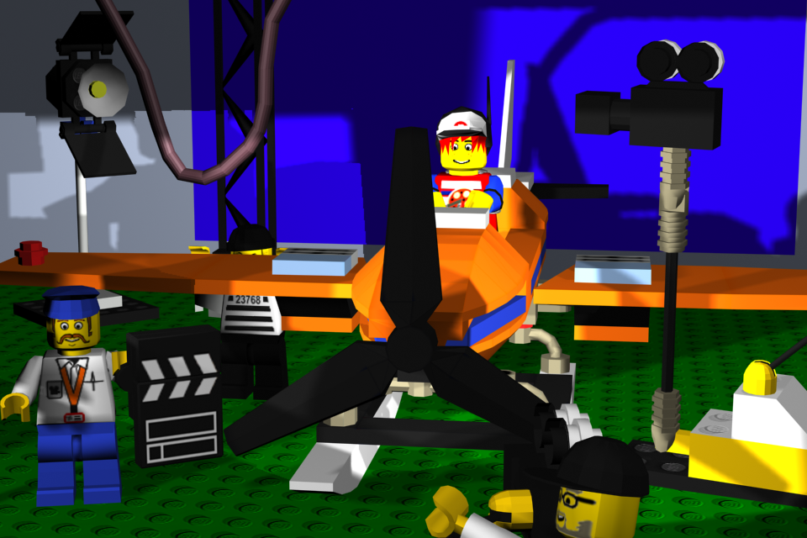
Running Through how each Blue Room works.

- Block Buster explains the run of the game, complimented with sketches of in game footage shown on the projection screen. This includes subtitles at the base of the screen (Borders).
- Subtitles are replaced with flashing text “Press ‘Start’ to begin” at the base of the screen. The projection screen displays icons of controls. The player can practice the controls, with Pepper reacting accordingly (Mario Party Style). This can be continued for as long as the player wishes.
- Pressing the ‘Start’ button will bring down the clapper board loading screen.
- The clapper board will rise to show the sub game.
- Play Game
- Successful ending will result in the clapper board coming back down and the Blue Screen loading.
- Clapper board rises to reveal the Blue Screen.
- Block Buster rewards Pepper with the appropriate award, while stills from the rush are shown on the projection screen. Includes subtitles at the base of the screen
- The subtitles are replaced with the option to ‘Retry’ or ‘Exit to LEGO island’.
- Selecting ‘Retry’ see (4)
- Selecting ‘Exit to LEGO island’ will fade out the screen. Loading the island.
- Pepper will be standing outside the appropriate building.

