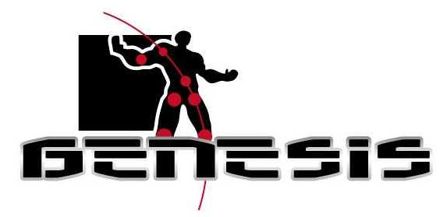

ACS Embedding Recommendations

Table of contents
Table of contents 2
1 Introduction 3
2 Overall procedure 3
2.1 Unprocessed Audio 3
2.2 Finding preferable masking sounds 3
2.3 Tech Toy side script 5
2.4 Notch filter 5
2.5 ACS Audio 5
2.6 Mix 5
2.7 Test with Tech Toy 6
2.8 Processed Audio 6
3 Minimum equipment requirements 6
Appendix A: Psycho-acoustic masking theory. 6

1 Introduction
The purpose of this document is to describe the procedure of manually embedding ACS audio into a program material containing audio, i.e. TV show, PC game, internet web side, Radio, etc. This document is written in a technical language, and it is therefore recommended to have an audio engineer degree or similar technical background to be able to follow the recommendations in this document.

The overall procedures are presented first and each operations are then described in more detail later in the document.

2 Overall procedure
Below is an example of an ACS embedding procedure regarding a TV show as program material:
Figure 1: Overall ACS embedding block diagram.

The above procedure can be used as a principle procedure for embedding ACS in all kinds of audio material.

2.1 Unprocessed Audio
This signal is the row audio in where the ACS signal should be embedded. The format of the signal should be in digital PCM with a resolution of at least 16 bits and 44.1 kHz sample frequency. (I.e. a wave file) If the signal is stored on an analog media, it is recommended to copy that into a digital format, to be able to use the following recommendation within the rest of this document.

2.2 Finding preferable masking sounds
To make the ACS audio as les hearable – and more magic – as possible, it is necessary to use psycho-acoustic masking techniques. To use these techniques it is necessary to do some signal analysis of the unprocessed audio.
The two types of masking used are described in more detail in appendix A.

To be able to find good spots where the two above described masking techniques will have an effect, it is necessary to view the unprocessed audio in both the time and frequency domain at the same time. So-called waterfall plots or spectrograms are good for that. 3D plots are also a possibility, but do not has the same immediately view as waterfall plots gives. Figure 2 shows an example of a waterfall plot with good masking sounds highlighted.

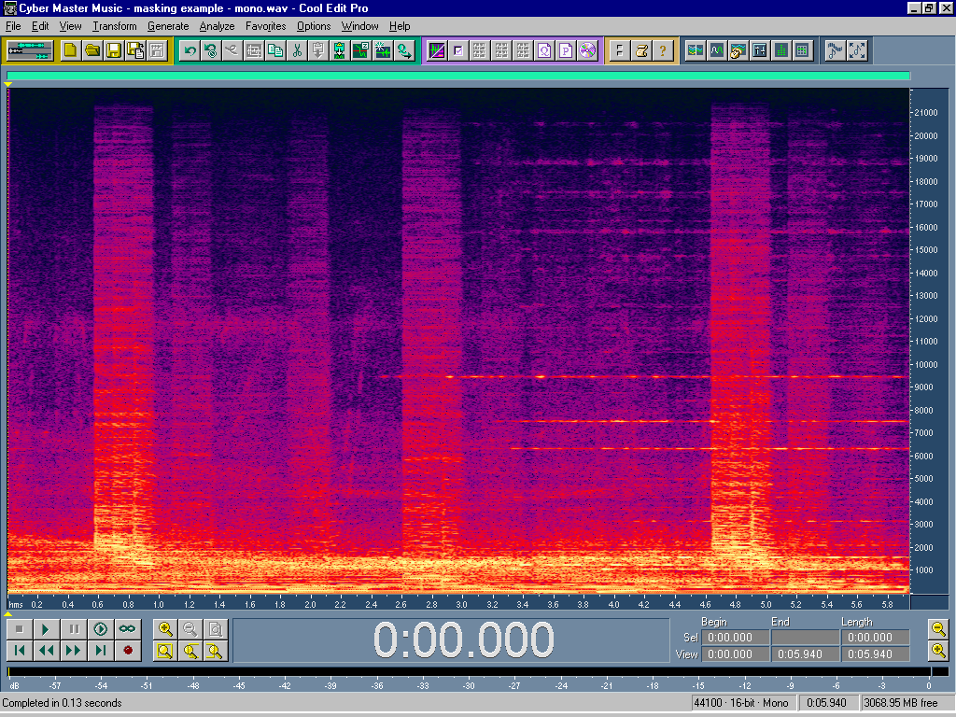
Good masking sound

Figure 2: Waterfall plot using Cool Edit Pro. X-axis presenting time, Y-axis presenting frequency
and Color presenting amplitude (bright color equal to high amplitude).

Besides looking at the waterfall plot listening to the sound is always a good way of finding good masking spots. By that it might be possible to find sound where the ACS audio could fit in as a contents related sound effect or a part of on.

Procedure of finding preferable masking sounds:
- Find the time code where the “Tech. Toy side script” indicates to have a response from the toy. (Should be where there is almost silence in the program material so the toy response could be heard above)
- Listen and display the time period about 100 seconds before that time and make a waterfall plot.
- Spot out areas where the highest amplitude in the frequency bands of minimum 7-11 kHz is presented (To obtain Simultaneous Masking).
- Make sure that these areas are longer than 200ms (100 ms to obtain Forward Masking plus duration of the ACS audio - normally les than 100ms pr. command).
- Look in the “Tech. Toy side script” to see how many times the same ACS command should be retransmitted (depending on the impotency of the commend getting trough to the toy). This amount should be the same as good masking areas within the 100 seconds. There can also be more than one command in each area.
- Note down the time code for these area(s). These time codes are used when inserting the notch filter (see chapter 2.x).
- Note down the time difference between the area(s) and the time code described in 1. This time differences are used when generating the ACS audio (see chapter 2.x).

Some sound effects and music are better than others to obtain masking effect. It takes a little bit of training to spot out these sounds. Dialogue or speech alone is usually bad sounds, be course the frequency normally stop at about 5-7 kHz, and masking can therefore not be done.

NOTE: This process will demand some training and experience, to be able find preferable masking sounds in the unprocessed audio for masking the ACS audio.

2.3 Tech Toy side script
A script having information about when the tech toy should response. This is done by a time code referring to the time code of the program material. This used in the procedure in chapter 2.2.
It also has information about the type of response (Playing speech or SFX, showing LCD picture, open a new game, Etc.). This is used when generating the ACS audio code (See chapter 2.x).

More explanation to come

2.4 Notch filter
The notch filter is inserted in the unprocessed audio material in the same time slot as where the ACS audio has to go in. This is done to make sure not to have the material represented in the frequency band as where the ACS audio is located. Otherwise the material will disturb or conflict with the ACS audio.

Filter requirements:
Center frequency: 9 kHz
Band wide: 4 kHz symmetric around the center frequency (7-11 kHz) .
Filter order: > 10. Order (Using digital filters higher order filters is easy to do)
Suppression in the stop band: > 40 dB

Procedure of inserting the notch filter:
- View the area around the time code noted down in chapter 2.2 point 6.
- Insert the notch filter only in the same time period as the duration of the ACS code plus 10 ms.

More explanation to come

2.5 ACS Audio
A computer program done by LEGO generates the ACS Audio file. The inputs to the program are:

- Command type (I.e. Play speech or SFX, show picture, open new game, etc.)
- Command (I.e. Which sound to play or picture to show)
- The time delay from the toy receive the code to the toy should response. (The time determined in chapter 2.2 point 7.)
- How many retransmissions needed. (Depending on how important it is for the toy to receive the code)

The output from the program is a wave-file.

More explanation to come

2.6 Mix
After the program material has been notch filtered the ACS audio code should be mixed in. This should be done in the exact same time period as the notch filter has been inserted.

Procedure of mixing in the ACS audio:
- The amplitude of the ACS audio should be adjusted so the peak level is xx dB below the amplitude of the program material measured in the frequency band of 7 – 11 kHz. More investigation needs to be done in this area to find the threshold between obtaining masking effect and having a secure data transmission.
- A test should be done with the tech toy to verify the code. (see chapter 2.7)

More explanation to come

2.7 Test with Tech Toy
More explanation to come

2.8 Processed Audio
More explanation to come

3 Minimum equipment requirements
The embedding procedures described in this document are in its principle way independent of the choose of equipment used. However, the list below shows an example of a very simple setup based around a computer.

- One high performance PC (minimum 1000Mhz, 256 MB of RAM, 40 GB of hard disk)
- One high performance PC sound card (AES/EBU or SPDIF digital I/O)
- A audio editing program tool (for example Cool Edit Pro)
- An ACS Audio generator program
- A loudspeaker monitor
- One Tech. Toy.

Beside of the list above, it is necessary to have a digital storage media with digital I/O for uploading and layback after embedding process have taken place.

Appendix A: Psycho-acoustic masking theory.

Simultaneous Masking.
More explanation and figures to come

Forward Masking.
